Horchata (made with rice)

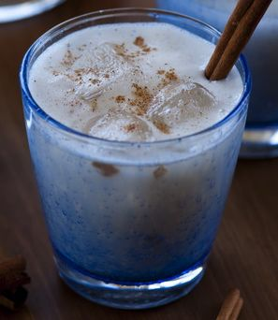

Ingredients:
- 1 cup uncooked long-grain, white rice
- 4 cups warm water
- 1/2 cup whole milk
- 2 teaspoons pure vanilla extract
- 1/2 teaspoon almond extract
- 1/2 teaspoon ground cinnamon
- 1/4 cup sugar
- Whole cinnamon sticks, optional, for serving

Directions:
In a blender, combine the rice and warm water. Blend for 1 to 2 minutes until the rice breaks up but does not form a powder. Let the rice mixture stand in the refrigerator for 6 hours or up to overnight.

Strain the rice mixture into a container through a fine-mesh sieve or several layers of cheesecloth to remove the rice solids. Rinse the blender out well.

Pour the rice water back into the blender and add the milk, vanilla and almond extracts, cinnamon, and sugar. Blend for 1 minute until well combined and smooth. Serve the horchata over ice with cinnamon sticks as stirrers.

