Habichuelas Rosadas con Jamón - Pink Beans with Ham (recipe serves two).
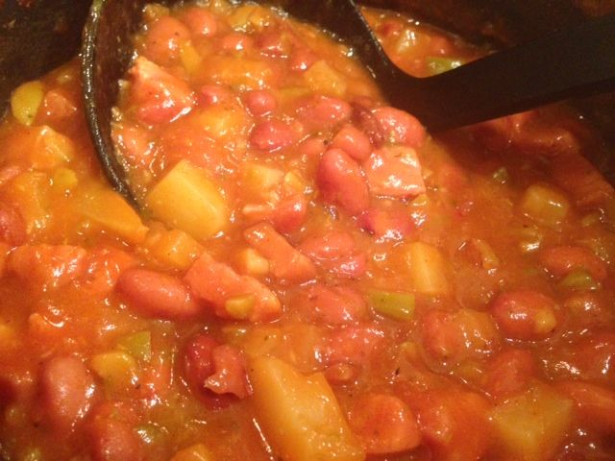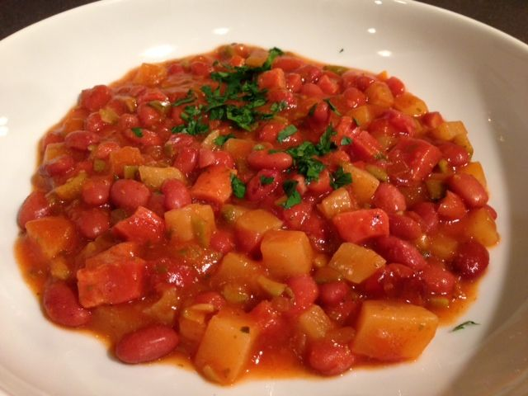
This Latino-Caribbean stew is a classic – it’s festive, filling and just too easy to make!
Ingredients;
1, 15-ounce can pink beans (“Habichuelas Rosadas” sold in the Latin-American aisle of your favorite grocery store – I use Goya or La Preferida brand), drained/rinsed
1 small bay leaf
¾ cup ham, chicken and/or vegetable broth
¼ - ½ cup zesty recaito (sold in the same place as the beans - I use Goya brand)
¼ - ½ cup alcaparrado (you have to make this yourself, but it’s really simple: Finely chop pimiento-stuffed olives with a tablespoon of capers)
8 ounces canned, Spanish-style tomato sauce (Goya brand - same place as the beans)
1 small russet potato (about 5 - 6 ounces), peeled and cut into ¼ -inch cubes
1 clove garlic, minced
4 – 5 ounces (about ½ - ¾ cup) smoked ham, cut into ¼ -inch cubes
½ teaspoon each of salt & ground, black pepper
minced chili peppers and/or crushed red-pepper flakes, to taste (optional)
cilantro or parsley, finely chopped for garnish (optional)

Preparation:
Mix all the ingredients well in a small saucepan. Cover, bring to a boil, lower the heat and simmer gently on low-medium heat until the potatoes are tender, about 30 to 45 minutes (cock the lid and even remove it from time to time, adjusting the heat to maintain a nice, rolling simmer, so the sauce reduces a little).

Sprinkle with a little chopped cilantro or parsley (if you happen to have any on hand) and serve in wide bowls by itself or with cooked, white rice (to taste).

