Green Poblano Rice for Two

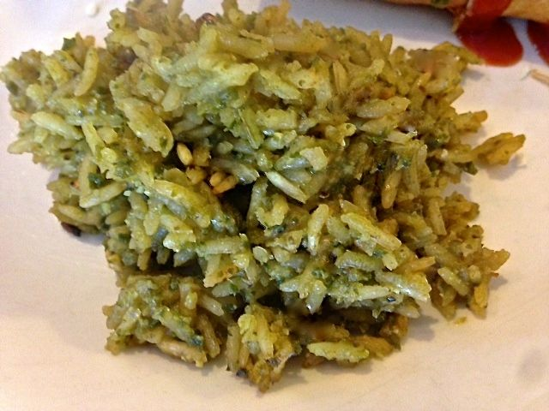

Ingredients:
2 tablespoons vegetable oil
1 small white onion, chopped
1 poblano chili stemmed, seeded and chopped
1 clove garlic, peeled and roughly chopped
¼ teaspoon salt
¼ teaspoon ground, black pepper
½ cup chicken broth, plus more if needed
½ cup long grain rice

Preparation:
Heat 1 tablespoon oil in a small saucepan over medium heat. Add the onions and sauté until translucent. Add the poblano chili and sauté, about 8 minutes. Mix in the garlic and cook until fragrant, about 1 minute. Season with the salt and pepper. Add ½ cup broth and bring to a boil. Turn off the heat and let cool.

Transfer the mixture to a food processor and pulse until smooth. Measure the liquid yield from the food processor, adding more chicken broth if necessary to yield 1 total cup of poblano liquid. Adjust seasoning to taste.

Meanwhile, wipe out the saucepan, place over medium heat and add the remaining tablespoon oil. Toast the rice until chalky, heavy and slightly golden. Pour the poblano puree into the saucepan and bring to a simmer. Turn down the heat to lowest setting and cover tightly. Cook for 15 – 20 minutes (until the rice is tender), turn off the heat and let rest for 5 minutes. Fluff with a fork before serving.

