Green Chili Enchiladas Casserole - recipe serves four (2 per serving)

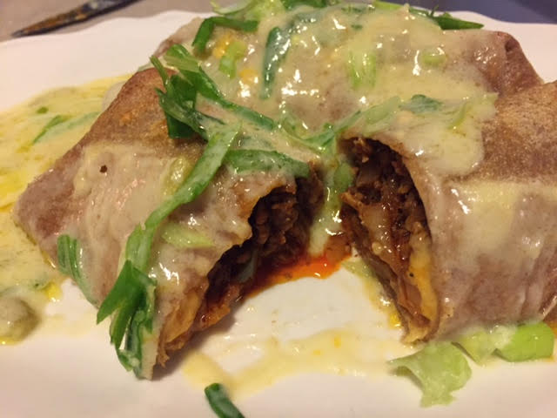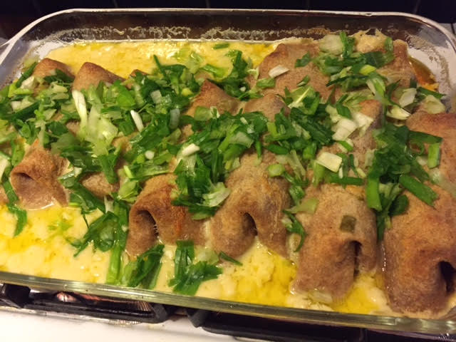

Ingredients:
1 pound ground beef, chicken, pork and/or chorizo
1 tablespoon vegetable oil
1 medium onion, thinly sliced
1 jalapeño pepper, seeded and finely diced (optional)
1 tablespoon chili powder
½ teaspoon cumin
½ teaspoon salt
¼ teaspoon pepper
8 soft flour tortillas (I use whole wheat)
8-ounce block cheddar cheese, shredded
1 10.75-ounce can cream of chicken soup
2 cups Mexican crema or crème fraîche
1 4-ounce can chopped green chilies
5 – 6 scallions, chopped

Preparation:
Preheat the oven to 375° F. In a large frying pan, heat the oil over medium heat. Brown the meat along with the sliced onions, diced jalapeno, chili powder, cumin, salt and pepper. Remove from heat, divide into 8 portions and set to one side.

Place a tortilla on a plate. Spoon ⅛ of the meat mixture and a handful of cheese onto half of it. Fold up the ends of the tortilla before rolling it across like a cigar, keeping the filling in place. Repeat with the remaining tortillas, placing them seam-side down into the bottom of a lightly greased 3-quart casserole dish. Fit them all in an even layer on the bottom.

Mix together the chicken soup, crema/crème fraîche and green chilies. Season with a little salt and pepper. Stir until the ingredients are combined. Pour the sauce over the enchiladas. If you have any of the cheddar cheese left over, sprinkle it on the top. Bake the casserole, uncovered, in the oven for 35 minutes. Serve garnished with the chopped scallions.

