Green-Chorizo Tacos

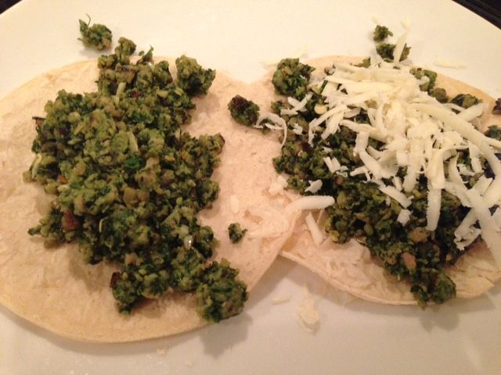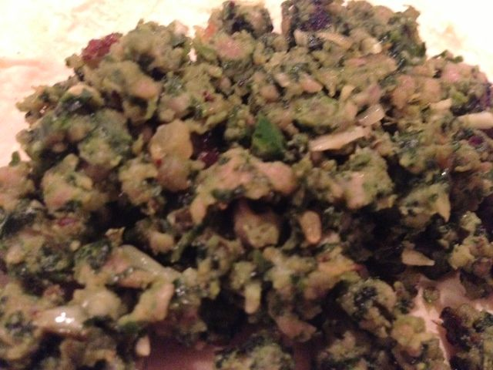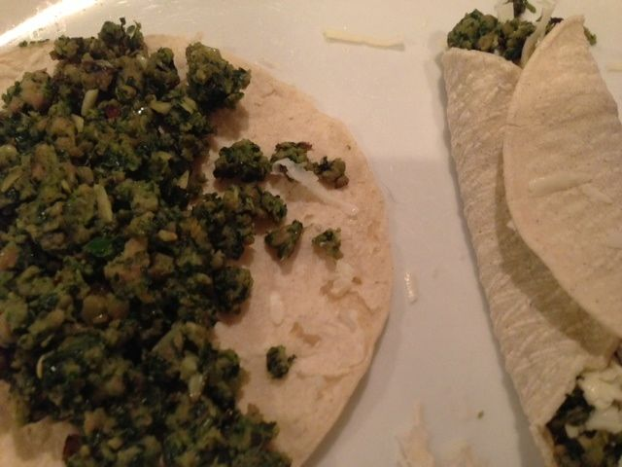

We all know and love deep-red, paprika-laced chorizo sausage. But green chorizo!? ¡Si! You can’t buy green chorizo in most North-American markets, though (even in Latin grocery stores), so you have to make it yourself. It’s really easy, but mind that the meat must marinate two hours! This recipe will render about 2 cups (16 ounces) of green chorizo which is the perfect amount to make four tacos (2 per serving).

Ingredients:
1 medium poblano chili
1 large Serrano chili, stemmed and roughly chopped
2 - 4 cloves fresh garlic, roughly chopped
¾ cup chopped cilantro
½ pound ground pork
3 tablespoons fresh parsley, chopped (1½ teaspoons dried parsley will do just fine)
1½ teaspoons salt
¾ teaspoon dried oregano (the Mexican kind, if you have it)
2 tablespoons recaito - my personal touch, so this it’s optional (I like Goya brand)
4 tortillas, grated Mexican or other cheese of choice, for garnishing tacos

Preparation:
Roast the poblano chili directly over a gas flame or 4 inches below a very hot electric broiler, turning regularly until blistered and blackened all over, about 5 minutes for an open flame, about 10 minutes for the broiler. Place the blackened chili between dampened paper towels and allow to cool down a little – you should see steam rise from it. When cool enough to handle, rub off the blackened skin, slice it open and scrape out all the seeds carefully with the back of a knife. DO NOT RINSE the blackened skin off or you will destroy the good flavor! Roughly chop and scoop into a food processor, along with the Serrano, garlic, cilantro and parsley. Pulse until evenly chopped, then run the machine until you have a coarse puree.
In a large bowl, combine the pork with the rest of the ingredients (except the tortillas, of course!) - I wear latex kitchen gloves so I won’t get the chili oils on/in my skin. Cover and refrigerate for at least 2 hours so the flavors can develop together.

Bring the mixture to room temperature and fry it in just a scant amount of oil (like ½ teaspoon) over medium-high heat in a skillet, crumbling it well as it browns. Warm up the tortillas a minute or two until they’re softened up in a skillet over medium heat and divide the mixture equally between them, sprinkle on some grated cheese of choice, roll up and serve with beans or Spanish rice on the side. The green chorizo also goes great over Huevos Rancheros.

