Spanish Gazpacho – recipe serves 2.

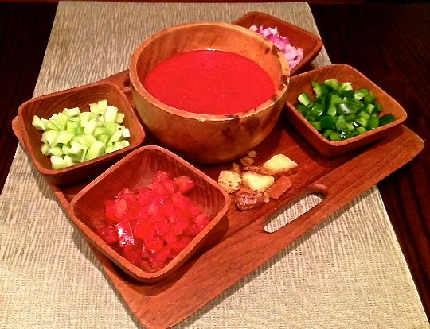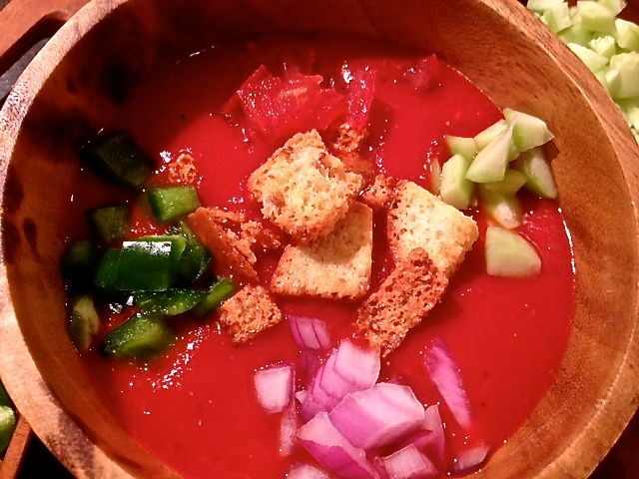

Gazpacho is a cold Spanish tomato-based raw vegetable soup, originating in the southern region of Andalusia. Gazpacho is widely consumed throughout Spain, neighboring Portugal (their word for it is gaspacho) and parts of Latin America. Gazpacho is mostly consumed during the summer months, due to its refreshing qualities. There are a number of theories about its origin, including as an Arab soup of bread, olive oil, water and garlic that arrived in Spain with the Moors, or via the Romans with the addition of vinegar. Once in Spain, it became a part of Andalusian cuisine, particularly around Seville, using stale bread, garlic, olive oil, salt, and vinegar, similar to ajoblanco (pale, white gazpacho). Tomato was added to the recipe in the 1700s. Traditionally, gazpacho is made by pounding the vegetables using a mortar and pestle. This method is still sometimes favored as it helps keep the gazpacho cool and avoids the completely smooth consistency, and foam, created by blenders and food processors.

Ingredients:
2 pounds fresh tomatoes, or two 14½-ounce tins canned tomatoes (use whole, peeled Italian San Marzanos)
1 small sweet onion (about 2 ounces – Vidalia works great), cut into 1-inch pieces.
1 small clove fresh garlic, peeled
½ teaspoon salt
1 tablespoon olive oil
2 tablespoons lemon juice, or to taste
1 teaspoon smoky Spanish paprika (pimentón)

Garnish per Serving:
1 – 2 tablespoons diced cucumber
1 – 2 tablespoons diced green bell-pepper
1 – 2 tablespoons diced tomato
1 – 2 tablespoons diced red/purple onion
¼ cup croutons.

Preparation:
Place all the ingredients, except the tomatoes and the garnish components, into a food processor. Pulse until smooth. Pour in the tomatoes and their juice (crush tinned tomatoes by hand, picking out any hard bits and skin). Pulse slowly, with deliberate on-off pulses, until the tomatoes are blended in smoothly. Do not blend in the tomatoes too quickly or they will aerate and turn pink. Test for seasoning – add more salt and/or lemon juice, if needed.

Chill well in the refrigerator before serving (at least one hour). Serve in wide bowls with the garnish components served separately on the side in little dishes/cups.

