Gambas a la Plancha (pan-grilled shrimp) for Two

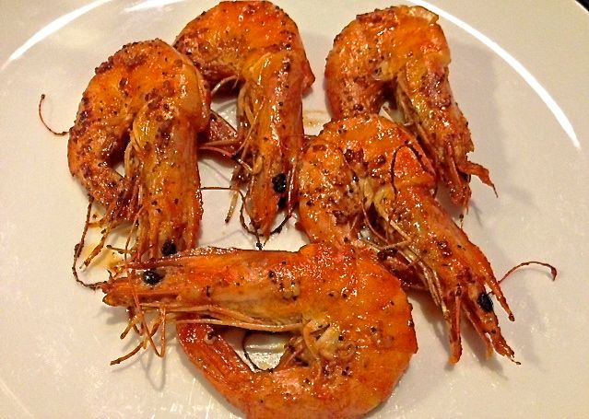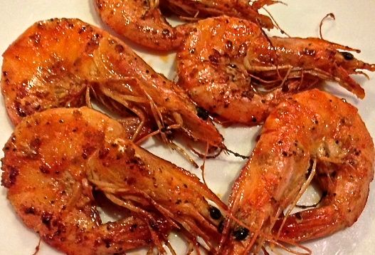

Spaniards love to eat grilled shrimp at the counter of good tapas bars while sipping a glass of chilled fino sherry or cold beer. The bars are always crowded with little-to-no space for proper dining, and it’s really interesting to watch the locals skillfully peel and eat shrimp with one hand while holding a drink in the other. Look for medium-large whole shrimp and leave the heads on for cooking. Sucking the juices from the flavor-packed heads of the cooked shrimp is the best part.

Ingredients:
¼ cup olive oil
3 tablespoons lemon juice
2 cloves garlic, minced
1 teaspoon salt
1 teaspoon ground, black pepper
1 teaspoon smoky, Spanish paprika
8 – 10 medium-large shrimp (about ½ pound, 4 – 5 shrimp per serving) in the shell with heads intact, if you can find them

Preparation:
Cut a slice down the back of the shell of each shrimp and devein (rinse out the dark intestinal track of each). In a bowl, whisk together the olive oil, lemon juice, salt, pepper, paprika and garlic until well blended. Marinate shrimp in the mixture up to 1 hour (I put them in a Ziploc bag in the fridge).

Heat a large, dry skillet over high heat. When the pan is very hot, add the shrimp in a single layer without crowding. Sear for 1 – 2 minutes on each side, until rosy and golden. When all the shrimp are cooked, arrange on cocktail plates and serve immediately with a glass of cold, Spanish sherry.

