Galician Stew (Caldo Gallego) - Recipe makes 2 servings.

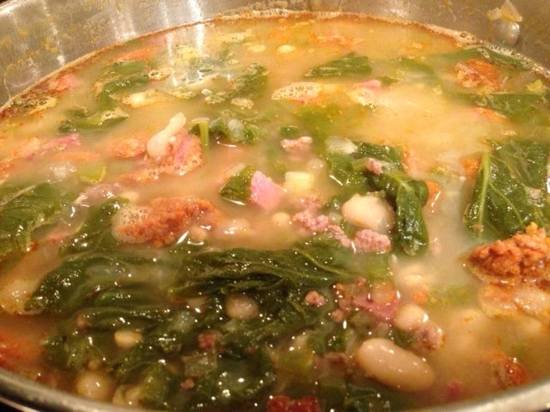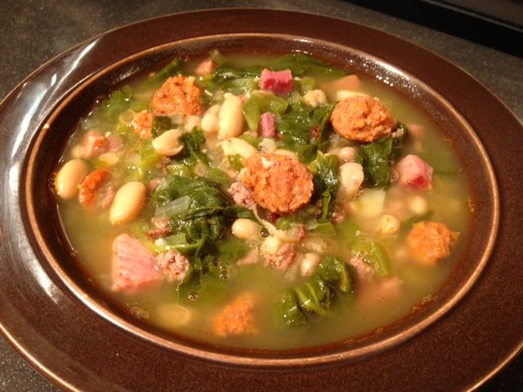
This soup comes from the region of Galicia in Spain, just north of Portugal. “Gallego” refers to someone or something from Galicia, while “caldo” means broth. Everyone has their own version of this, with beans, pork of some kind, greens and whatever else is in season.

Ingredients:
1, 15½-ounce can navy/white beans or Cannellini beans, drained and rinsed
2 ounces Spanish chorizo (not the Mexican kind)
2 ounces pound beef – you can use chuck, rump roast, etc., diced (I like to fry ground sirloin for this!)
2 ounces smoked ham, diced
1 small onion (about 2 ounces), finely chopped
1 clove of garlic, finely chopped
1 small rib celery, finely chopped
½ a green bell pepper (or a very small one), finely chopped
2 ounces turnip greens without stems (tender leaves only)
3 cups water
1 small potato, peeled and diced small
1½ teaspoons salt
¾ teaspoon ground pepper
1 chicken bouillon cube, plus an equal amount of ham bouillon (if you’ve got any – if not, use more chicken bouillon)

Preparation:
Place the beans in a large saucepan with the water. Dissolve the bouillon cube in a little hot water, then add to the pot with the beef (I fry and crumble 2 ounces of ground sirloin for this), ham, bell pepper, onion, potato and garlic. Cover and bring to a boil, set heat to low, let simmer partially covered until the beef pieces start to fall apart a little and the potato is fairly tender, about 1½ hours, stirring occasionally. To insure the caldo remains nice and clear, skim the foam from off the surface and discard it with a large spoon from time to time, as it develops, while simmering.
Cut the chorizo into ¼ -inch slices. Add the salt and pepper (I season everything as I go), chorizo and turnip greens to the pot and let simmer for another 30 minutes. Taste and adjust for salt and pepper. Serve hot with crusty bread.

