Fajitas – recipe serves 2.

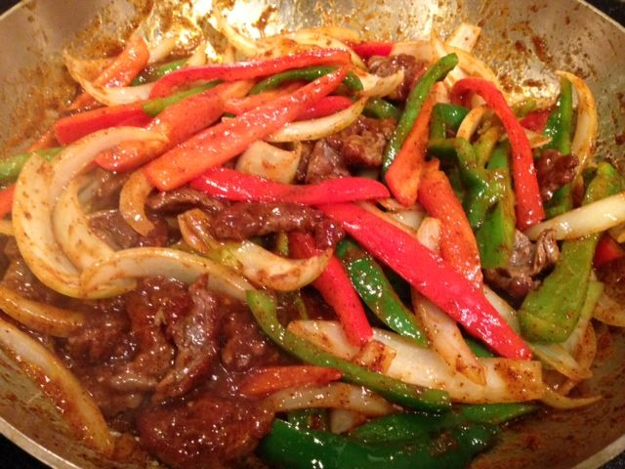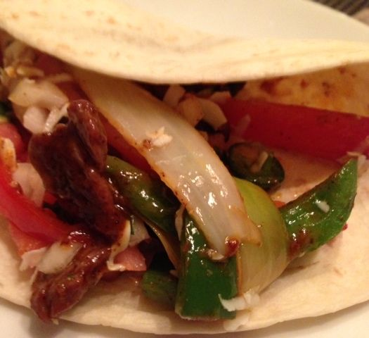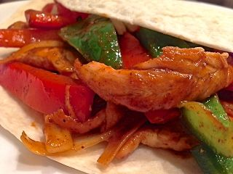

For the Fajita Seasoning
1 tablespoon cornstarch
2 teaspoons chili powder
1 teaspoon salt
1 teaspoon paprika
1 teaspoon sugar
1 teaspoon crushed chicken bouillon cube
½ teaspoon onion powder
¼ teaspoon garlic powder
¼ teaspoon cayenne pepper
⅛ teaspoon crushed red-pepper flakes
⅛ teaspoon cumin

Combine all of the ingredients in a small bowl. To store, pour into small glass or plastic container, seal tightly and keep in a cool, dry place. Makes 1½ ounces of Fajita seasoning mix, but without all the salt that comes in the commercial brands.

For the Fajitas
½ pound boneless, skinless chicken breasts or skirt steak– cut into thin strips (or just get chicken tenders already in thin portions; be sure to tenderize skirt steak well with a kitchen hammer or prick it deeply with a fork all over)
1 small green bell pepper, cut into long strips/slices
1 small red bell pepper, cut into long strips/slices equal to the green pepper
2 tablespoons oil
The Fajita seasoning mix from above (I use half of it - ¾ ounce - and save the rest for another time)
⅓ cup water
1 small, white onion, cut into strips/slices, as equal as possible to the bell peppers
½ cup salsa or pico de gallo (see my recipe), ½ cup sour cream (optional – we don’t like it)
¼ to ½ cup grated Cheddar or Mexican white cheese, like cotija (optional, but I like it)
4 small or 2 large flour tortillas (NOT optional!)

Preparation:
Heat a large skillet until good and hot over high heat, then add in the oil. Add the meat and caramelize for 5 minutes. Then add the fajita seasoning mix, water, green & red pepper and onion.

Reduce heat to medium-high. Sauté until meat is cooked through and vegetables are tender. Serve with salsa, pico de gallo and grated cheese in warmed tortillas.

