Authentic Mexican Enchiladas for Two (makes 2 per serving)

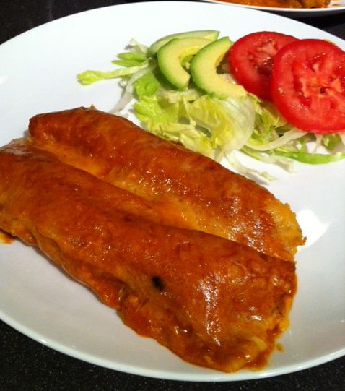

Ingredients:
4 ounces meat, like ground sirloin or ½ cup chicken meat – I like to use shredded, rotisserie-chicken (all the dark meat and the pieces of white meat that don’t come off with the whole breast halves, which I freeze and save to dice up in Cajun/Creole recipes – I give the wings and a drumstick to my hungry spouse to eat while I make dinner!)
4 corn tortillas
vegetable oil – use peanut, canola or other type with high smoking point
1 – 2 cloves fresh garlic, minced
¾ cup to 1½ cups mild Cheddar, Chihuahua or other Mexican white cheese, grated
¼ cup (one very small, 2-ounces’ worth) yellow onion, finely chopped
Red/Cayenne pepper
12 ounces enchilada sauce (see my recipe for enchilada sauce)

PREPARATION:
Preheat oven to 350º F.

The Meat Filling: Sauté the onions and garlic until caramelized in a large skillet. Add in the meat and sauté until browned (crumbling beef finely). Remove to a large bowl and mix in 3 tablespoons of the enchilada sauce, ¼ cup of the cheese, ¼ teaspoon salt, and red/Cayenne pepper to taste (I use about 1½ teaspoons); set aside.

The Tortillas: Pour enchilada sauce (half of the rest of the bottle) in an 9” x 9” baking dish. Heat a few teaspoons of oil to coat the skillet. WARNING: The rest of the recipe is really messy! Dip a tortilla in the sauce in the Pyrex dish to coat the tortilla with sauce on both sides. Place the tortilla in the skillet and fry for a few seconds, until the tortilla just begins to turn soft and delicate. Use tongs to gently flip to the other side for a few more seconds. Gently “pour” the tortilla out of the skillet onto a plate, using the tongs to very gently coax it out. Repeat with remaining tortillas, adding more oil to the skillet as necessary, and rotating the plate around as you pour out each softened tortilla.
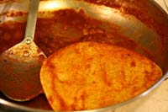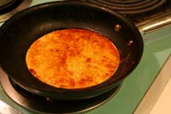

Assemble the enchiladas. I wear washed, latex gloves to do this! Divide the meat mixture into four, equal portions, placing each portion in the center of a tortilla and carefully rolling up afterwards. Place each in the baking dish seam-side down, repeating until you have four neatly placed in a row in the casserole dish. Cover the tortilla rolls with the remaining sauce.

Sprinkle with the remaining grated cheese. Place in the oven and cook for 10 – 15 minutes, or until the cheese is bubbly.

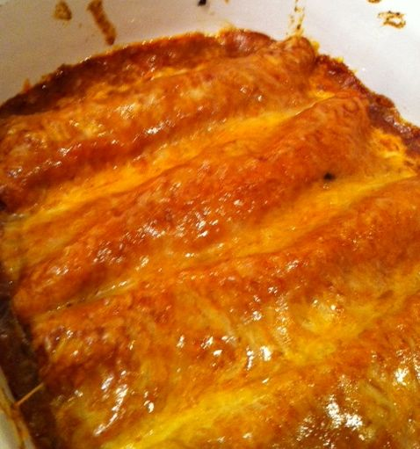

Use a spatula to serve. Spoon remaining sauce from baking dish onto the plates, over or around the enchiladas.

Serve with thinly sliced iceberg lettuce next to them on the plate, seasoned with a squirt or two of lime juice or vinegar and a light sprinkle of salt (no oil), guacamole or avocado slices, and sour cream. Garnish with cilantro.

Notes:
This has got to be one of the messiest recipes I’ve got! Wear and apron or at least make sure you’re not wearing any clothes you don’t mind completely spattering with the damned sauce. Be prepared to have to clean your kitchen from top to bottom, too, after making these. But they’re so worth it!

