Homemade Enchilada Sauce (recipe makes 1½ quarts)

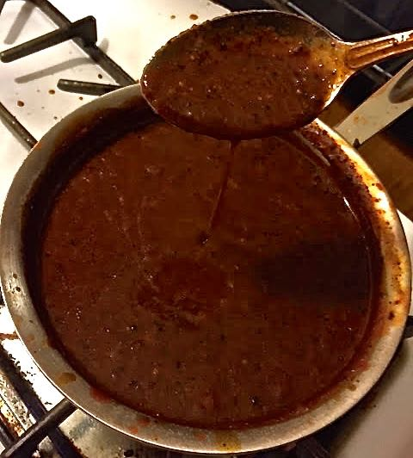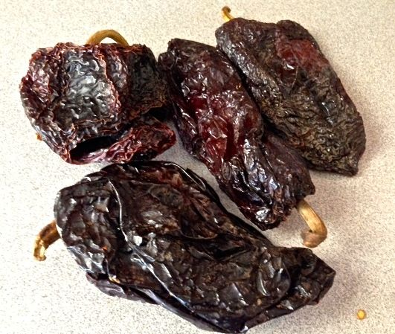

In Spanish, “enchilado/a” means to be “chilied.” It’s a Tex-Mex thing. Along with tomatoes, the base of this sauce is made from dried ancho chilis. You can find dried ancho chilis at any Mexican grocery and even at regular grocery stores these days. They are not spicy, but rather have a chocolatey quality to them. Make sure that the dried chilis you buy are soft and pliable, not stiff and crispy.

Ingredients:
1 – 3 dried ancho chilis
1 tablespoon cumin seeds
1 tablsepoon garlic powder
2 teaspoons dried oregano (preferably the Mexican variety)
3 tablespoons vegetable oil
3 tablespoons all-purpose flour
½ teaspoon salt
½ teaspoon ground, black pepper
2 cups chicken or vegetable broth
2½ cups (24 ounces) tomato juice – I use a bottle of Italian tomato passata
2 teaspoons white vinegar

Preparation:
Seed and tear into pieces about ½ cup's worth of dried ancho chili. Toast the torn pieces with the cumin seeds over medium-low heat in a pan 'till fragrant. Allow to cool, then grind into a fine powder with the garlic powder and oregano using a spice grinder or coffee grinder.

Put the oil in the pan, heat it up to just shimmering over medium high heat; add in the ground spice powder along with the flour, salt and pepper. Cook until the mixture takes on a dark color and becomes fragrant and thick. Next, whisk in the broth, tomato juice and vinegar. Let simmer over medium heat for ten minutes.

Now you’re ready to make enchiladas with the sauce!

