Eggs with Chilis and Cheese for Two (juevos y chilis con queso por dos personas)

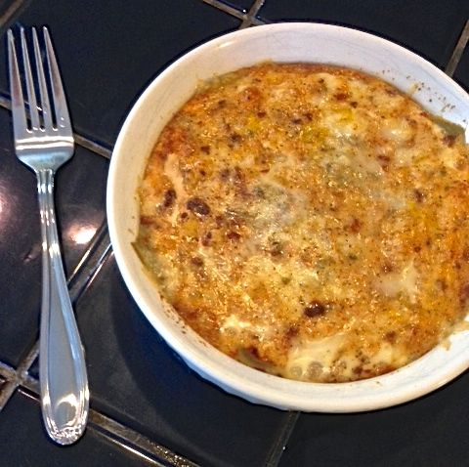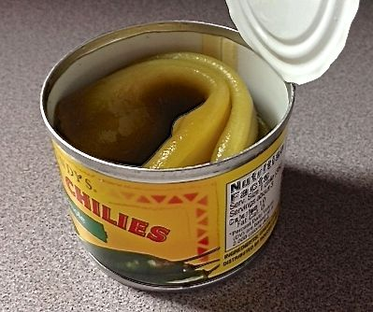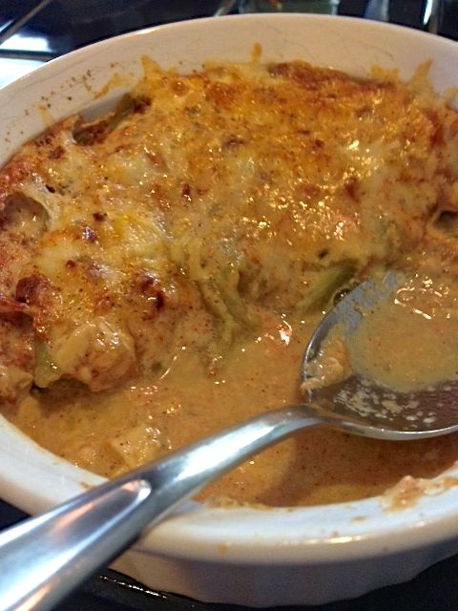

Ingredients:
8 ounces whole, green chilis, roasted, peeled and seeded – they’re sold ready-to-serve in little 4-ounce tins which each contain either 2 big ones or 3 smaller ones rolled up (2 of the 4-ounce cans provides the perfect number)
8 ounces Monterey jack and/or pepper jack cheese, grated
3 whole large eggs
¼ cup whole milk
Salt and ground, black pepper, to taste
½ teaspoon paprika
¼ - ½ teaspoon cayenne pepper, or to taste

Special Equipment: 1 round ramekin between 5” – 5½“ in diameter by 2” – 2½“ deep; a larger, deeper baking dish in which you can place the ramekin, and; a turkey baster.

Preparation:
Preheat oven to 325° F.
Cut open each chili lengthwise, open them up and lay 2 – 3 down flat in a single layer over the bottom of the ramekin. I find it easiest to cut them open with sheers.

Top the chilis with half of the cheese. Repeat with another layer of chilis and another layer of cheese. You can also layer in a little fried chorizo, ham or fried bacon bits before baking. The dish can be covered and refrigerated until you’re ready to eat.

Beat the eggs with the milk, salt, pepper, paprika and cayenne.
Pour the egg mixture over the top, then place the ramekin into the larger dish. Carefully pour water into the larger baking dish until it meets the top level of the layered mixture in the ramekin. Bake for 45 minutes, or until completely set.
Siphon out the hot water from the larger dish with your turkey baster before removing the ramekin – mind that it’ll be hot. Cut in half and serve with warm corn tortillas. These are good any time of the day, for breakfast, lunch or dinner.

