Dominican Republic “Chimi” Sandwiches for Two

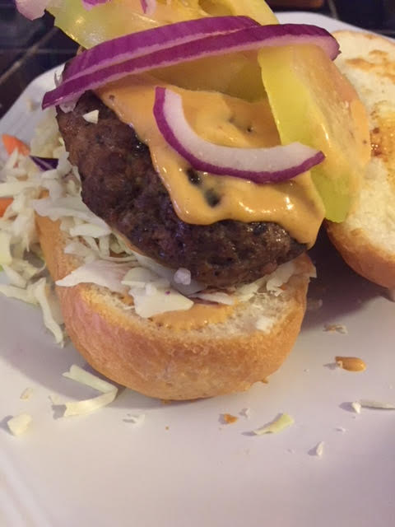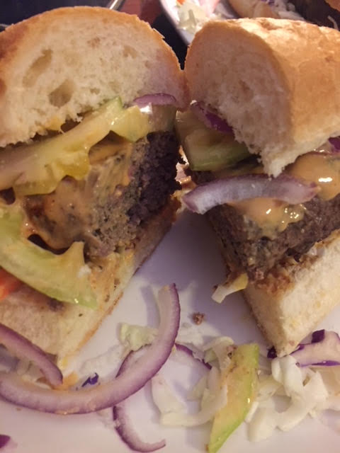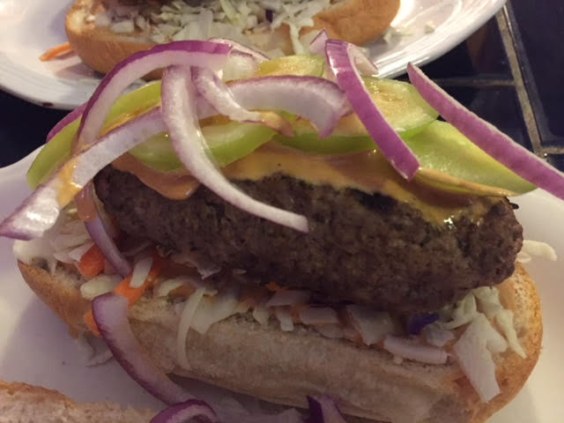

In the Dominican Republic, they call these “chimis.” They call the special sauce that goes on top “chimichurri,” although it is absolutely nothing like Argentinean chimichurri. It is made by combining equal portions of mayonnaise, ketchup and yellow mustard. Lots of oregano is the hallmark of Dominican cooking!

Ingredients:
½ pound ground beef
½ pound ground pork or pork sausage
2 individual baguette, bolillo or bratwurst buns
1 tablepoon dried oregano (use the Mexican variety, if you can find it)
1 teaspoon granulated garlic powder
¼ cup sour orange juice (“naranja agria” – found in any Latin grocery; you can substitute in ½ part lemon juice and ½ part lime juice, with a splash of regular orange juice)
1 teaspoon salt (the regular kind – not kosher)
½ teaspoon ground, black pepper
3 tablespoons mayonnaise
3 tablespoons ketchup
3 tablespoons yellow mustard
Raw cabbage/carrot coleslaw mix
1 green tomato, sliced thinly
1 small red onion, thinly sliced
Hot sauce of choice, to taste

Preparation:
Thoroughly combine the ground beef and pork with the oregano, granulated garlic powder, slat, pepper and sour orange juice (naranja agria). Form into narrow, flat oval patties and fry until well browned on the outside on both sides, at least 15 minutes total.

Make the “chimichurri” sauce by combining the mayonnaise, ketchup and mustard.
Slice open bread and slather the bottom portion with sauce, then scatter shredded cabbage and carrots over it. Place the fried patties on the buns and slather them with the rest of the sauce. Top with sliced green tomato, sliced red onion and finish up by drizzling a little hot sauce over it.

