Cuban Fried Beef (Vaca Frita) for Two

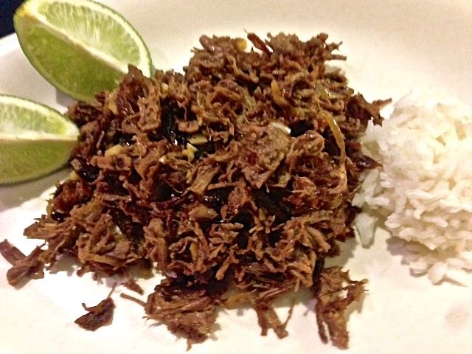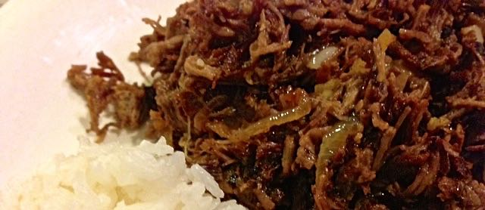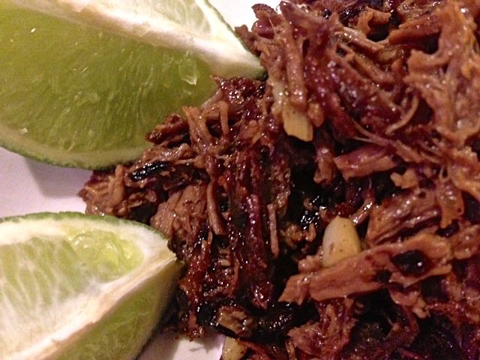
Ingredients:
1 pound boneless beef chuck-eye roast (regular chuck roast works just fine), trimmed of most fat and cut into 1½” cubes
Salt and ground, black pepper
3 garlic cloves, finely minced
½ teaspoon vegetable oil, plus more for frying
¼ teaspoon ground cumin
¼ cup naranja agria (a sour citrus juice sold at most Latin markets), or 4 teaspoons orange juice mixed with the grated zest of a lime and 4 teaspoons limejuice
Lime wedges, for serving (NOT optional)
1 small onion, halved and sliced thinly
1 tablespoon dry sherry

Preparation:
Bring beef, 1 cup water, and ¾ teaspoon salt to boil in a 9” or 10” skillet over medium-high heat. Lower the heat, cover, and gently simmer until beef is very tender, about 1 hour 45 minutes. Check beef every 30 minutes, adding water so that bottom third of beef is submerged. While beef simmers, combine garlic, oil & cumin.

Remove lid from skillet, increase heat to medium, and simmer until water evaporates and beef starts to sizzle. Transfer beef to foil-lined baking sheet. Reserve fat in the pan. Place sheet of aluminum foil over beef and, using meat pounder or heavy sauté pan, pound to flatten beef into ⅛”-thick pieces, discarding any large pieces of fat and connective tissue. Separate into shreds with two forks.

Heat reserved fat in the skillet over medium-high heat. When fat begins to sizzle, add onion and ¼ teaspoon salt. Add more oil, if necessary to cook the onions. Cook, stirring occasionally, until onions are golden brown and caramelized. Add sherry and 4 teaspoons water, and cook until liquid evaporates. Transfer onions to a bowl. Return skillet to high medium-heat, add 3 tablespoons more oil, and heat until it begins to sizzle. Add beef and fry it, stirring frequently, until dark golden brown and crusty.

Reduce heat to low and push beef to sides of skillet. Add garlic mixture to center and cook, stirring frequently, until fragrant and golden brown. Remove pan from heat, add naranja agria or orange juice mixture and onions, and toss to combine. Season with pepper to taste. Serve with lime wedges to squeeze over and boiled, white rice.

