Cuban Chayote Salad

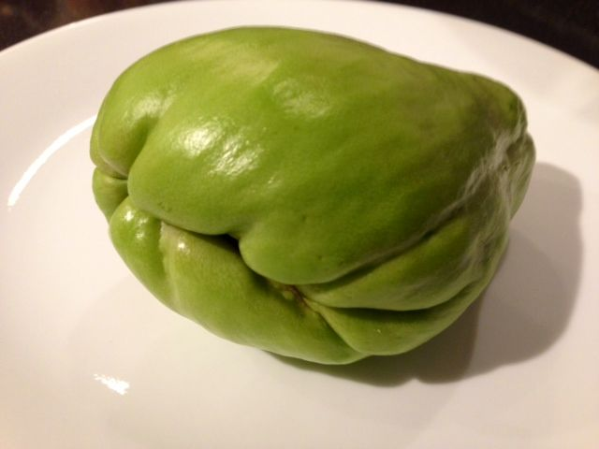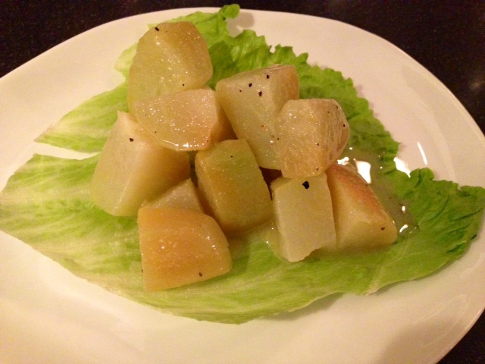

Ingredients per Serving:
1 chayote squash per serving – they are also known as “chokos” in French-speaking countries, “meletons” and, where I come from, “mirletons” – they’re the size and shape of a pear and light green in color, tasting like a cross between a potato and an unripe pear.
½ teaspoon dried mustard
¼ teaspoon salt
¼ teaspoon black pepper
¼ cup olive oil
2 tablespoons lime juice

Preparation:
Peel the chayote as you would a potato, remove the tough inner seed pocket and chop into 1” cubes. Boil until tender for 15 minutes. Strain into a sieve and run under cold water until chilled down. Let the chayote drain thoroughly.

Mix the rest of the ingredients into a dressing and pour over the cubed chayote. Refrigerate for at least 1 hour before serving over lettuce leaves.

