Cuban Fufú

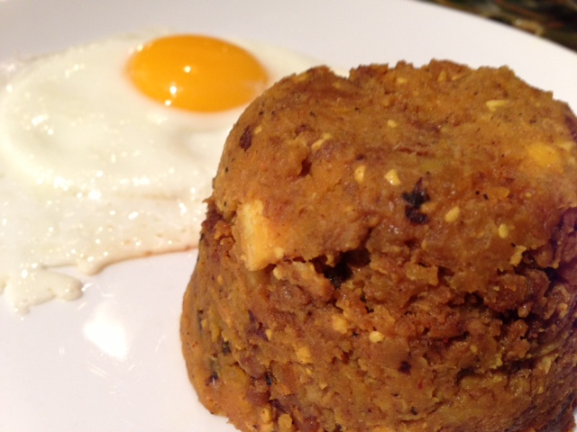

This is the Cuban version of the garlicky-goodness they call “mofongo” in Puerto Rico and “mangú” in the Dominican Republic where they normally eat it in the morning for breakfast. It and its name are West-African in origin, having been derived from a mashed-yam dish from that part of the world. Versions of this recipe vary from place to place in the Caribbean, but this is a principal variation of it.

Ingredients for Two Servings:
4 ounces Spanish chorizo, bulk/removed from casing
1 green plantain, peeled and sliced into 2” chunks
¾ cup chicken or pork stock/broth
2 large cloves garlic, smashed
½ teaspoon turmeric
2 tablespoons lemon juice (the juice of one lemon)
¼ teaspoon salt and ground, black pepper
Oil for frying

Preparation:
In a small saucepan, fry the chorizo until nicely browned. Remove to the side.

In the saucepan, fry the plantain chunks in the chorizo grease and a little extra oil until they get some color on them, 3 – 5 minutes, then add the lemon juice., the broth, garlic, turmeric, salt and pepper. Bring to a boil, then turn down heat to medium and simmer, uncovered, 6 – 8 minutes at a rolling boil.

When plantains are soft enough to mash, mash them up until smooth, then add in the fried chorizo and stir well. It should have the consistency of mashed potatoes.

Serve hot with fried eggs on the side!

