Colorado Pork Chili for Two

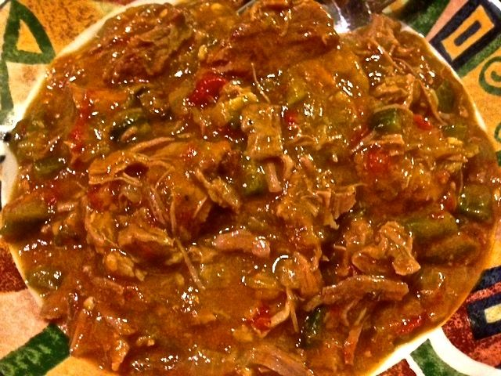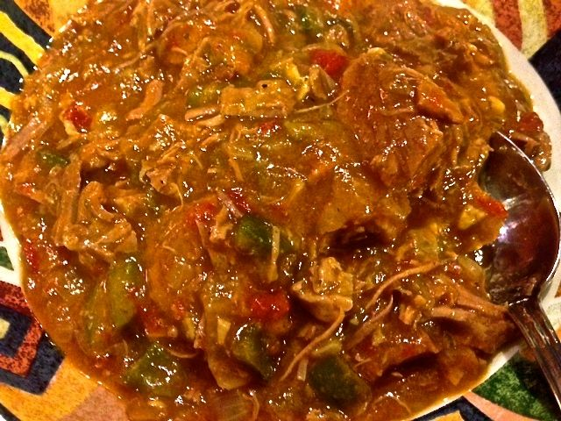

Ingredients:
1½ pounds boneless pork butt roast, trimmed of fat and cut into 1” pieces
Salt
1 pound (6 – 7) hatch or Anaheim chilis, stemmed, halved lengthwise, and seeded
1 – 2 jalapeño chilis, whole
½ a 14.5-ounce can whole San Marzano tomatoes with their juices
1½ teaspoons vegetable oil
1 onion, finely diced
4 garlic cloves, minced
1½ teaspoons ground cumin
3 tablespoons all-purpose flour
2 cups chicken broth
Cayenne pepper

Preparation:
Adjust oven rack to lowest position and top rack 6 inches from broiler element. Heat broiler. Arrange Anaheims, skin side up, and jalapeños in single layer on a foil-lined baking sheet. Place sheet on upper rack and broil until chilis are mostly blackened and soft, 15 to 20 minutes, rotating sheet and flipping only jalapeños halfway through broiling.

While chilis roast, combine pork, ¼ cup water and ¼ teaspoon salt in a large, ovenproof saucepan over medium heat. Cover and cook for 20 minutes, stirring occasionally. Uncover, increase heat to medium-high, and continue to cook, stirring frequently a few more minutes, until liquid evaporates and pork browns in its own fat. Transfer pork to bowl and set aside.

Set the jalapeños aside and place the Anaheims in large bowl and cover with plastic wrap; let cool for 5 minutes, then remove skins from Anaheims. Heat oven to 325° F.
While oven heats up, chop half of Anaheims into ½” pieces and set aside. Process remaining Anaheims in a small food processor until smooth, then combine with the chopped Anaheims. Pulse tomatoes and their juice in empty food processor until coarsely ground, about 4 pulses.

Heat oil in empty saucepan over medium heat until shimmering. Add onions and cook until lightly browned. Stir in garlic and cumin and cook a few seconds until fragrant. Stir in flour and cook for 1 minute. Stir in broth, Anaheims, tomatoes, and pork with any accumulated juices and bring to simmer, scraping up any browned bits. Cover pot, transfer to lower oven rack, and cook until pork is tender, around 1 hour to 1 hour and 20 minutes.

Without peeling, stem and seed jalapeños and reserve seeds. Finely chop jalapeños and stir into chili. Season chili with salt, cayenne, and reserved jalapeño seeds to taste.

