Cochinita Pibil - Mayan recipe for pulled pit-pork from Mexico’s Yucatán Peninsula. Recipe serves 2.

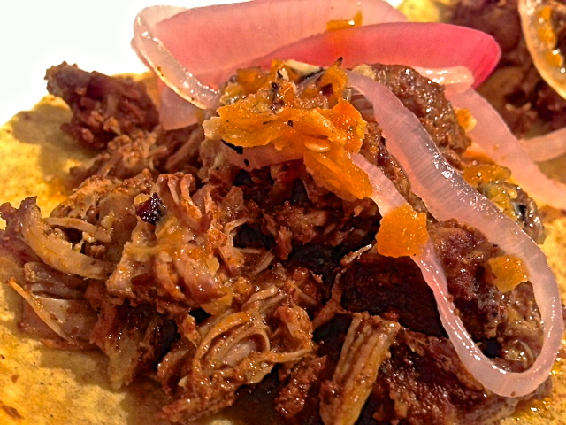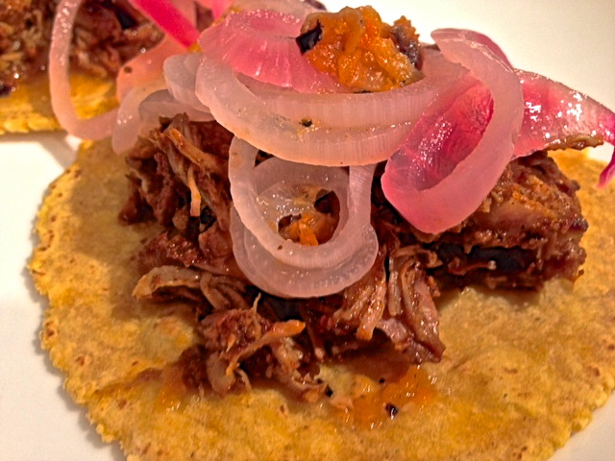

Ingredients:

1 pound boneless pork shoulder “Boston butt” roast, cut into 3” – 4” chunks

3 average-sized garlic cloves, peeled and roughly chopped

2½ teaspoons annatto/achiote (pronouncd “ah-chee-oh-tay”) seeds, available at Latin grocery stores
¾ teaspoon dried oregano (preferably the Mexican variety)
¾ teaspoon black-pepper corns
¼ teaspoon whole cumin seeds
1 whole clove
¾ teaspoon cinnamon (preferably the Mexican variety), freshly ground or a 3” stick

¼ cup sour-orange juice (Naranja Agria juice sold in Latin groceries – the whole recipe requires 12 ounces), or you can substitute in 3 tablespoons fresh limejuice plus 3 tablespoons orange juice
Corn tortillas
For the Pickled Red Onions
2 – 4 ounce red onion (a small one), sliced into rings ⅛” thick
1, 12-ounce bottle sour-orange juice (Naranja Agria – also available at the Latin grocery), or substitute with 6 ounces limejuice mixed with 6 ounces orange juice
For the Roasted Habanero Salsa
2 medium-sized, fresh habanero chilies
1 average-sized garlic clove, unpeeled
1 tablespoon limejuice
⅛ teaspoon salt, or to taste

Preparation:
To make the achiote marinade, put the achiote seeds and oregano into a spice grinder with the black pepper, cumin, cloves and cinnamon; grind until everything is as fine and powdery as you can get it. In a small food processor, combine the ground mixture with ½ teaspoon salt, the garlic and ¼ cup of the sour-orange juice. Blend until smooth, until you feel very little grittiness when rubbed between your fingers. Clean out the food processor and set aside to make the salsa.

In a large bowl or quart-sized Ziploc bag, combine the meat and marinade, coating the meat evenly. Cover (or zip up the bag) and marinate in the refrigerator overnight.

Mind that the onion pickle and salsa must marinate overnight, too.

In the Yucatán, it’s absolutely mandatory to garnish cochinita pibil with these pickled onions. To make them, put the onion rings into a non-aluminum bowl (I like to use an oval 1½ -quart ceramic baking dish that has a glass lid). Mix the remaining sour-orange juice (or the lime-orange combo) with ¼ teaspoon salt. Cover the onions with boiling water and wait half a minute, then strain the steaming onions and return them to the dish. Pour the remaining juice completely cover the onions, submerging them all as best as you can manage. Cover and refrigerate overnight.

Make the habanero salsa to dress the meat. In a small, ungreased skillet over medium-high heat, roast the chilies and garlic, turning constantly, until they’re soft and blackened in spots, 10 to 15 minutes. Slip the skin off the garlic and add it with the roasted chilies, the limejuice, salt and 2 tablespoons of water to the food processor. Pulse until smooth. It’s not a lot, but it’s HOT! Put it in a small container, cover and refrigerate until the next day.

The next day, place the pork and its marinade in a 2-quart slow-cooker. Cover and cook on the low setting 10 to 12 hours. The pork can also be baked in a 325° F. oven instead of in a slow-cooker; tent the meat loosely with foil before baking.

Remove cochinita pibil and shred it with a pair of forks; set out with a large fork and spoon (for spooning up the juices). Pile the cochinita pibil onto warmed, corn tortillas. Drain the onion pickle and set it out in a serving bowl to top each portion with tiny dabs of the salsa.

The finished dish will keep for a couple of days, covered and refrigerated, though the texture of the meat won’t be quite as nice as fresh-from-the-pot. Warm refrigerated cooked meat slowly in a 300° F. oven in the juice, covered. The onion pickle will keep for a week or so in the refrigerator, well covered.
