Chuletas de Cerdo a la Madrilena (Madrid-style pork chops)

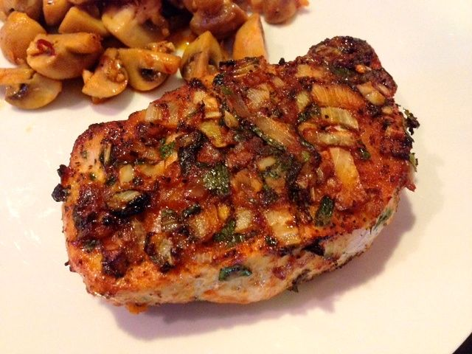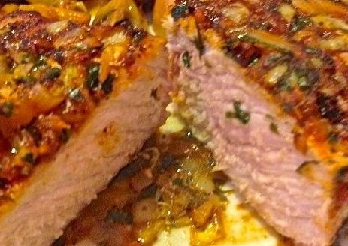

Roasted pork chops smothered with onions, garlic and smoky paprika, this dish is wonderful any time of the year. It’s served today with roasted or whipped potatoes on the side.

Ingredients:
2 pork chops – I use boneless, center-cut loin chops at least 1“ thick completely trimmed of all fat
1 small (about 2 ounces) yellow/Spanish onion, minced
3 tablespoons olive oil
2 fat cloves garlic, minced
1 – 2 teaspoons parsley (however much you like), minced
1½ teaspoons smoky Spanish paprika
Salt and ground, black pepper, to taste

Preparation:
Preheat oven to 425° F.

Mix the onion, garlic, parsley. paprika, salt, pepper and olive oil into a thick marinade4.

Grease a roasting pan or line it with aluminum foil. Smear the chops with the paste mixture, spooning it liberally over both sides.

Roast uncovered for 15 minutes, then turn the chops and roast another 12 – 15 minutes.

Spoon any sauce in the pan over the chops to serve with potatoes of choice.

