Chorizo-Stuffed Poblano Chilies – recipe makes 2 servings.

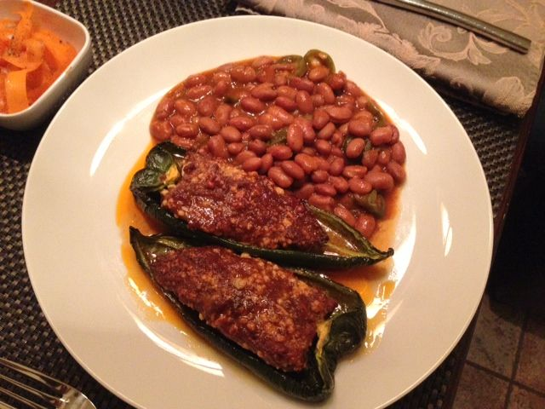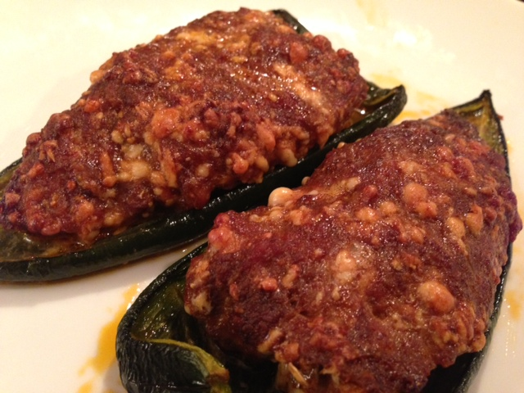

Simple to make, rich and satisfying, earthy and mild, these Mexican favorites are actually enjoyed all over the Americas. One out of maybe a hundred poblano chilies ends up being somewhat spicy, so don’t be too afraid of this recipe if you’re not terribly amenable to spiciness!

Ingredients:
2 large poblano chili peppers
¾ pound chorizo sausage (bulk/removed from casing)
½ cup queso blanco (Mexican white cheese), Cheddar cheese, whatever you like

Preparation:
Preheat oven to 375º F.

Rinse off chilies, cut evenly in half (long-ways), clean out seeds and place open-side up on a foil-lined baking sheet. Blend the chorizo with the cheese – I use my hands, but I wear latex gloves. Fill each pepper-half cavity with an even amount of the chorizo-cheese mixture (2 filled halves per serving).

Bake for 30 minutes.

Serve with ranchero beans or La Preferida brand Spanish rice!

