Spanish-Style Chorizo Chicken Wings Tapa for Two

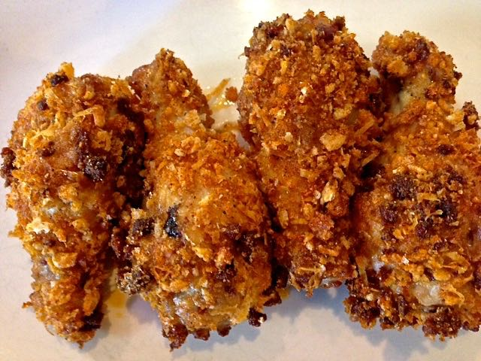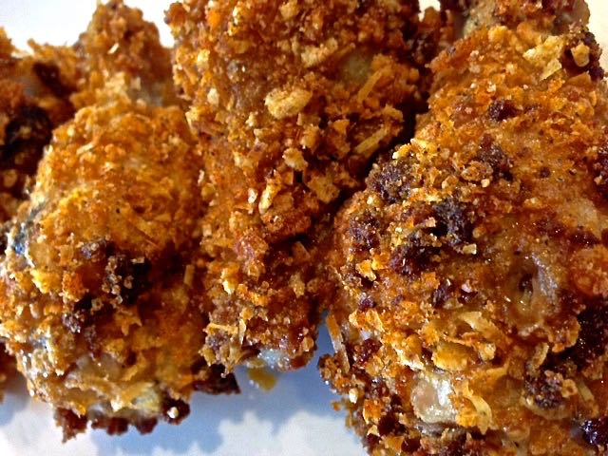

Ingredients:
1 – 1¼ pounds chicken drumettes (10 drumettes) or whole wings (cut in half at the joint)
1½ teaspoons olive oil
1¼ ounces hard-cured, Spanish-style chorizo sausage, finely chopped in food processor
1 cup puffed-rice cereal, like Rice Krispies (very popular in Europe)
4 tablespoons freshly grated Parmesan cheese
1 teaspoon smoky Spanish paprika
½ teaspoon ground cumin
¼ teaspoon salt
Ground black pepper, to taste
¼ cup mayonnaise
1 garlic clove, minced
1 teaspoon sherry vinegar

Preparation:
Preheat the oven 400° F.

Cut off the very tip of the chicken wings, known as the wing tips, and reserve for stock. Bring a small skillet to heat over medium heat, then add in the oil and bring it to heat. Add the chorizo and sauté, stirring, until lightly browned. Drain on paper towels if a lot of grease after frying and let cool to room temperature.

Place the rice cereal in a quart-sized Ziploc bag and roughly crush with a rolling pin. Transfer to a bowl and stir in the cooked chorizo, cheese, paprika, cumin, salt and pepper. Save the Ziploc.

Combine the mayonnaise, garlic, and vinegar in a measuring cup, then spoon into the empty Ziploc (I mix it all up in the Ziploc). Add the chicken wings in and toss well to coat. Remove wings from the Ziploc, one at a time, and roll in the cereal mixture until well coated. Arrange in one layer on a greased rack placed in a parchment-lined baking sheet and bake 35 – 40 minutes, until internal temperature reaches 165° F. Serve hot.

