Chipotle Pale Ale Chili – recipe serves 2

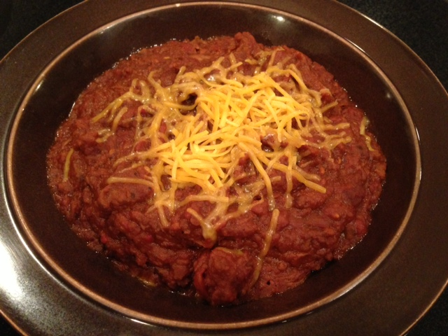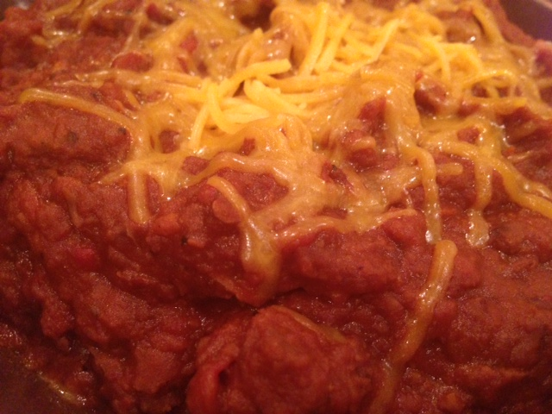

Ingredients:
½ pound chuck or sirloin steak, cut into smaller, ½“ cubes
¼ pound ground sirloin
½ cup pale ale
2, 14-ounce cans whole tomatoes (I normally crush them by hand, but not this time)
1, 16-ounce can refried beans (fat-free works fine)
2 chipotle peppers in adobo sauce, or as many as you can stand
1 tablespoon ground cumin
3 cloves garlic, minced
Salt and ground, black pepper, to taste
Granulated garlic powder, to taste
Shredded cheese, for garnish

Preparation:
Season the meat well with a sprinkling of salt, pepper and garlic powder. Brown all of the meat in a large, dry saucepan over high heat until well seared – leave the ground beef in large crumbles.

Add the cumin and stir for a few seconds until fragrant. Add all of the other ingredients, and season with another good sprinkling of salt and pepper.

Simmer uncovered over medium-low heat for 2 – 3 hours, until the steak cubes are fork-tender and the chili has reduced and thick to your liking (thin with water or tomato juice if it becomes too thick before the meat is tender). Check seasoning and add more adobo sauce from the chipotles, to taste.

Garnish with grated cheese and serve hot.

