Chimichurri Sauce (Argentinian Steak Marinade) for Two

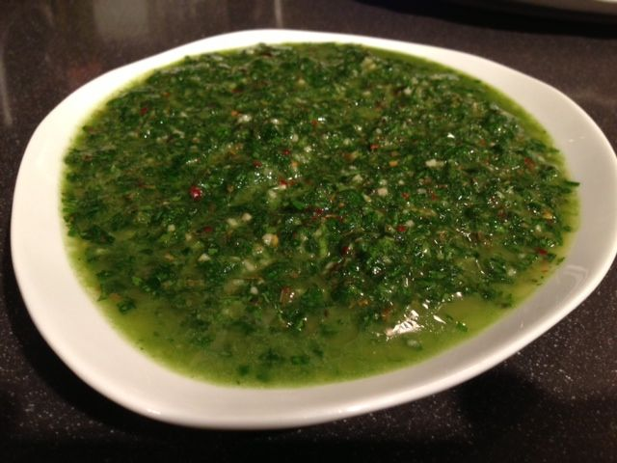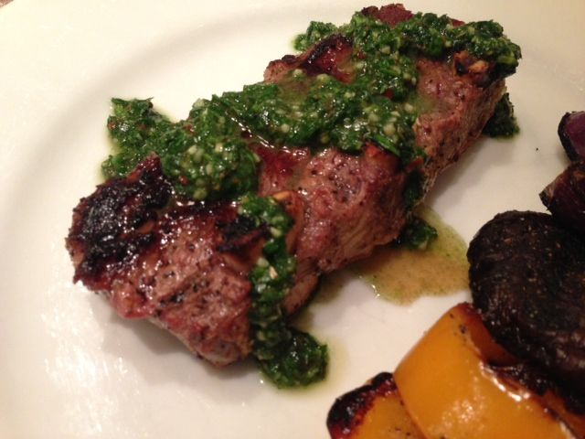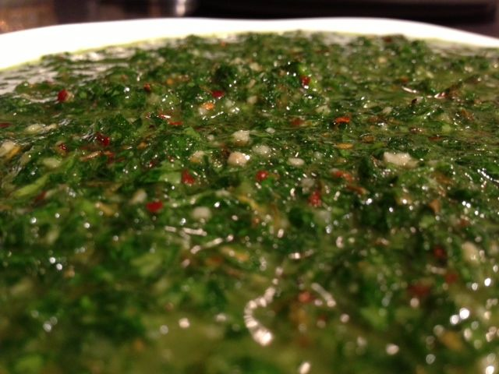

This sauce is so easy to make and is as essential to Argentinean grilled steak as the steak itself! Just lightly dress grilled asado with it for an authentic, Argentinean touch.

Ingredients:
3 tablespoons hot water
1 teaspoon dried oregano
1 teaspoon salt
3 tablespoons red-wine vinegar
11 tablespoons loosely-packed, flat-leaf parsley
5 tablespoons loosely-packed cilantro leaves
3 cloves garlic, minced
¼ teaspoon red pepper flakes
¼ cup extra-virgin olive oil, or whatever kind tastes best to you

Preparation:
Place the salt and oregano in a small bowl and pour the hot water over them. Let steep about five minutes.

While the oregano-salt mixture steeps in the hot water, pulse the parsley, cilantro, garlic and pepper flakes in a food processor until it’s roughly chopped.

Next, pour the oregano-salt mixture into the food processor, along with the vinegar. Pulse until well blended.

Scrape the mixture from the food processor into a bowl. Whisk in the olive oil, little by little, until nicely emulsified.

Cover the bowl with cling film and let sit out on the counter at least one hour so all the flavors marry together. Store unused sauce in the refrigerator and let come to room temperature before serving again.

