Jeff’s Chili con Carne for two

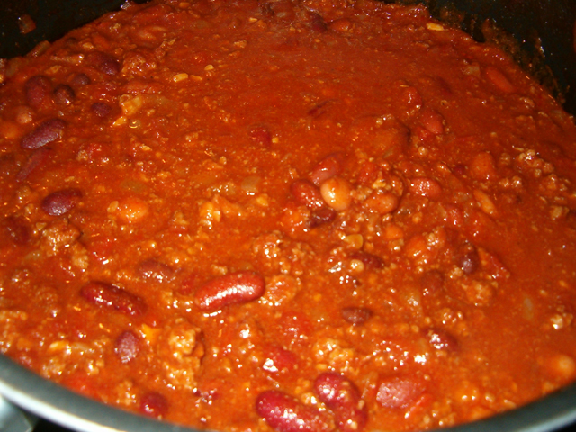

Ingredients:
¾ pound beef chuck roast, trimmed of major fat pieces and gutted of all gristle and tough bits, coarsely-ground in a food processor
1 small Spanish/yellow onion, chopped to a fine dice
1 fresh Serrano or other fresh chili pepper, diced finely
½ of a 16-ounce can light kidney beans, rinsed and drained (see notes)
½ of a 16-ounce can black beans, rinsed and drained (see notes)
½ of a 16-ounce can dark kidney beans, rinsed and drained (see notes)
½ of a 16-ounce can pinto beans, rinsed and drained (see notes)
1, 14½-ounce can whole San Marzano tomatoes, with juices crushed by hand
6 tablespoons tomato paste
@ 17½ ounces tomato sauce (more or less)
1 tablespoon jarred minced garlic, or 1 - 2 crushed, fresh garlic cloves
2 - 4 cloves roasted garlic (optional, but adds a very nice character to the chili)
1½ teaspoons beef-flavored browning liquid (see notes)
3 tablespoons lime juice
3 tablespoons lemon juice
½ teaspoon each of garlic powder, salt and ground, black pepper
¾ teaspoon ground cumin
Mild, dark chili powder and more salt, to taste (see directions)
Preparation:
Place the meat in a large saucepan over medium-high heat. Season the meat with the garlic powder, salt, black pepper and cumin; sauté it in its natural juices (i.e., don't drain the fat!), breaking it up so it's nice and chunky. After there is no longer any pink color to the meat, add the chopped onion, chilies, fresh and roasted garlic (mashing up the roasted garlic well), then let it simmer uncovered a good 10 minutes on medium heat.
Next, add the tomatoes, crushing them by hand, the tomato paste, tomato sauce, the beans, beef browning liquid and citrus juices (all the rest of the ingredients), season with a little more salt. Using just enough chili powder to cover the top of the pot's contents with a very thin layer of it twice (i.e., do it two times in a row).
Give it a thorough stir, cover and simmer gently on very low heat (just so there's a little bubbling to it), stirring occasionally, 2 hours. Finish by seasoning with salt to taste.

Notes:
I use "B-V Broth and Sauce concentrate" for the browning liquid. I save the other half of the beans and freeze them for making the chili again another day.

