Chickpea and Chorizo Soup – recipe serves 2

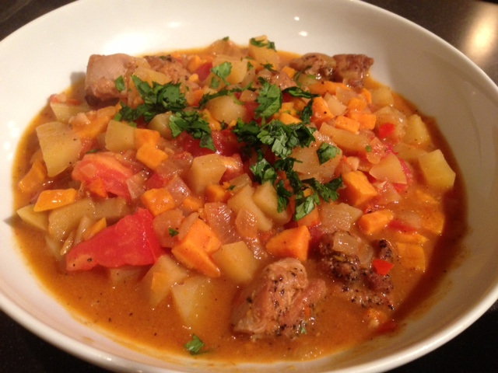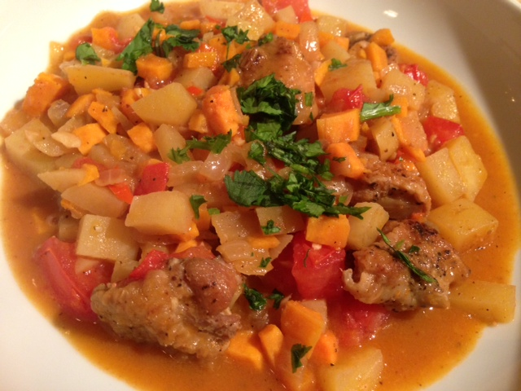

Ingredients:

1 small onion (about 2 ounces), chopped
1½ teaspoons olive oil
1 small carrot, peeled and diced
1 small/thin rib celery, diced
1 small potato, peeled and diced
7 ounces stewed tomatoes, chopped
1 1/3 cups chicken stock
7 ounces chickpeas (garbanzo beans)
2 ounces diced chorizo sausage
1 tablespoon fresh flat-leaf parsley, chopped
Croutons, to serve
Salt, to taste
Ground, black pepper, to taste

Preparation:
Heat the oil in a stock pot and cook the onion until soft and translucent.

Add the stock, tomatoes, carrots, celery, potato and chickpeas. Cover and simmer for approximately 25 minutes or until all vegetables are tender.

Add the chorizo and heat through.

Just before serving, sprinkle with parsley and croutons.

