Buñuelos de Queso (Cheese Puffs)

Brought to the New World by the Spanish, these are widely enjoyed throughout Latin America. These are actually fritters which are normally deep fried, but this recipe makes these a little healthier by baking them in the oven!
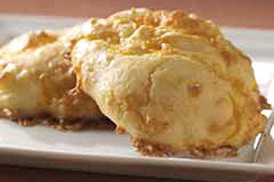

INGREDIENTS:

1 cup flour
2-1/4 tsp. baking powder
1 cup water
1/4 cup (1/2 stick) butter
3 eggs
1 cup shredded extra sharp Cheddar cheese
1 tsp. salt

PREPARATION:

PREHEAT oven to 425°F. Combine flour and baking powder; set aside. Bring water and butter to boil in heavy saucepan on medium-high heat; continue boiling until butter is completely melted, stirring occasionally. Remove from heat.
ADD flour mixture gradually, stirring until mixture is well blended and dough pulls away from side of pan. Place dough in large bowl. Add eggs and salt; beat on medium-high speed with electric hand mixer until dough is smooth and glossy. Fold in cheese by hand with a wooden spoon. Drop dough by tablespoonfuls onto greased baking sheet.
BAKE 15 min. Reduce oven temperature to 350°F. Bake an additional 25 min. or until puffs are golden brown and sound hollow when lightly tapped. Serve warm.
Makes: 15 servings (two buñuelos each). Recipe may be cut in half.

