Champiñones al Ajillo (garlic mushrooms)

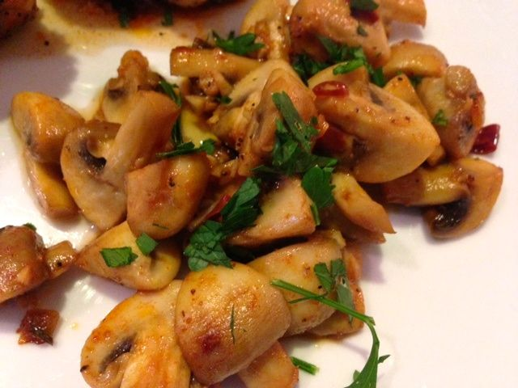

Few tapas taste more Spanish than Champiñones al Ajillo (pronounced “champ-peen-yon-ace ahl ah-heelo”), dripping with olive oil, garlic and dry sherry. To make this tapa even more authentic, be sure to serve the mushrooms with plenty of fresh, crusty bread to mop up the delicious juices.

Ingredients:
¼ cup olive oil
8 ounces mushrooms, wiped clean and quartered
3 cloves garlic, minced
5 teaspoons dry sherry
1 tablespoon lemon juice
1 - 2 dried, red chilies, minced, or ¼ teaspoon red-chili flakes
¼ teaspoon Spanish paprika
Salt and ground, black pepper, to taste
1 tablespoon chopped parsley

Preparation:
Heat the oil in a skillet and sauté the mushrooms over high heat for about 2 minutes, stirring constantly.

Lower the heat to medium and add the garlic, sherry, lemon juice, dried chili, paprika, and salt and pepper.

Cook until the garlic and mushrooms have softened.

Remove from the heat, sprinkle with chopped parsley, and serve warm.

