Catalan Tomato Bread (in Spanish, it’s “pan con tomate” and in Catalan, it’s “pa amb tomàquet”)

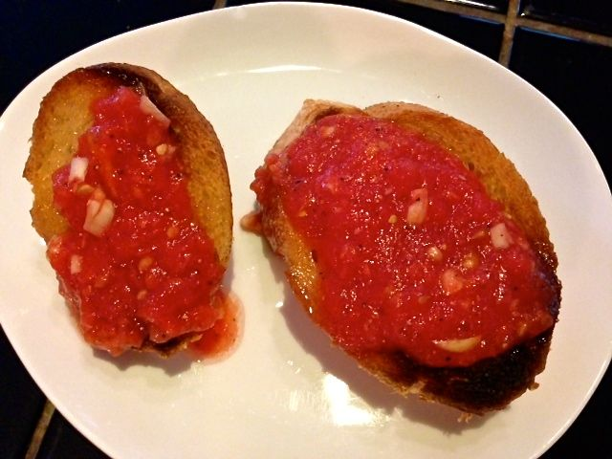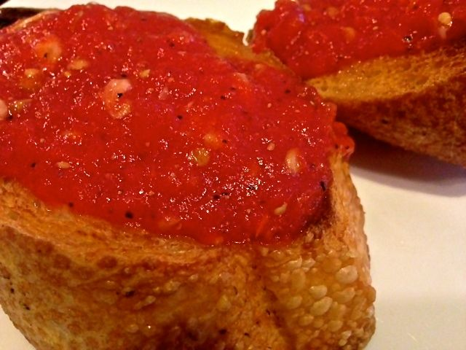

This version of the recipe makes a sauce from ripe tomatoes and fresh garlic which is different from the traditional recipe that calls for rubbing sliced garlic and tomato halves on the bread. It’s a quick and simple recipe that is colorful and appealing for breakfast, or as a mid-afternoon or evening snack. Serve with coffee for breakfast, or with beer or wine, olives and slices of cheese as a snack.

Ingredients:

10-inch baguette

2 juicy, ripe tomatoes, peeled (see note)
1 clove garlic
3 - 4 tablespoons olive oil
Salt and ground, black pepper, to taste

Preparation:
Cut the baguette length-wise and toast the cut sides on a hot grill, under a broiler, or in a toaster oven. (If short baguettes are not available, simply cut a standard size baguette into a 10” length.)

Peel the tomatoes and place in a food processor (see note). Peel garlic clove and place in food processor with tomatoes. Process until tomato and garlic are crushed and thoroughly mixed. Season with a little salt and pepper.

Drizzle olive oil over toasted sides of baguette. Spoon tomato mixture on bread and spread evenly.

Note:
Here’s a tip for Peeling Tomatoes: Bring approximately 2 cups of water to a boil in a small saucepan. Using a slotted spoon or tongs, dip each tomato into boiling water for about 30 seconds and remove. Place in a bowl of cold water. Remove and peel should rub off easily.

