Catalan Beef Stew – dark and rich, a unique way to stew beef (serves 2)

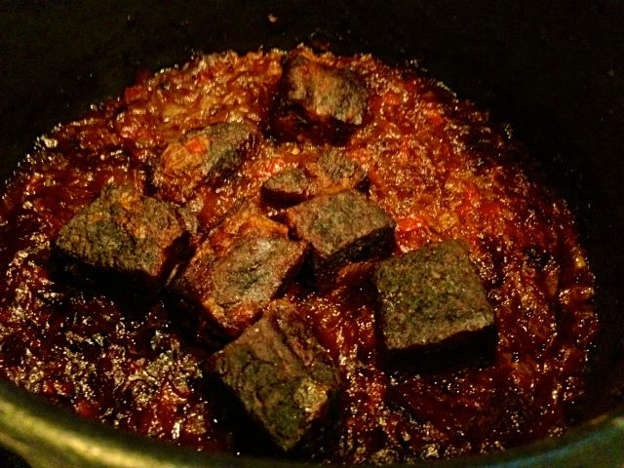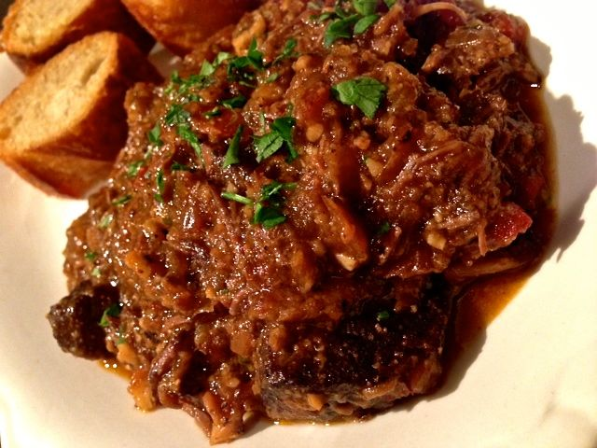

Ingredients:
¾ pound boneless English-style beef short ribs (may substitute with boneless beef chuck steak)
½ teaspoons salt & ¼ teaspoon ground, black pepper
1 tablespoon olive oil
1 medium Spanish onion, finely diced
¼ teaspoon salt mixed with ¼ teaspoon sugar
1 plumb tomato, cut in half and flesh grated large shred with skin finely chopped
½ teaspoon smoky Spanish paprika
1 small bay leaf
¾ cup water mixed with ¾ cup dry, white wine
⅛ teaspoon dried thyme mixed with ⅛ teaspoon ground cinnamon
⅛ cup whole, raw unsalted hazelnuts or almonds
1 slice bread, crust removed and torn into 1” pieces
1 clove fresh garlic, crushed and rough chopped
1½ teaspoons fresh parsley, minced
3 - 4 ounces oyster mushrooms, chopped
½ teaspoon sherry vinegar (may substitute with ⅛ teaspoon sherry and the rest rice wine vinegar)

Preparation:
Preheat oven to 300° F. Trim fat and silver skin off ribs. Cut beef into big, 2” pieces. Toss the beef and coat well with ½ teaspoon salt and ¼ teaspoon pepper.

Heat oil in a large heavy-bottomed, oven-proof pot over medium heat. Add in the onion and season them with the salt and sugar. Let the onion caramelize about 30 – 40 minutes, until they’re really reduced down and super-well browned.

When onions are caramelized, add in the tomato gratings, bay leaf and paprika. Cook over medium-low heat until most of the liquid (if any) is evaporated. Stir in the water, wine, thyme and cinnamon. Bring it up to a bubbling simmer.

Stir in the unbrowned beef into simmering liquid, then place the pot into then oven, uncovered. Cook for 1 hour before stirring and then baking a further 1½ hours. Turn meat again and bake a final 30 minutes, until the meat is very tender and well browned. Add ¼ cup water if stew gets too dry.

Make a picata by first toasting the nuts in a tablespoon of olive oil in a small skillet over medium-high heat. Remove browned nuts to a food processor. Add the torn bread pieces to the skillet and fry in the remaining oil until well toasted on all sides. Put toasted bread in food processor with nuts. Add in the garlic and pulse until finely ground. Add in the parsley; mix well.

Add another tablespoon of oil to the skillet. Season the mushrooms with a little salt & pepper and sauté a few minutes until browned and softened. Remove from heat and retrieve the stew from the oven. Add the mushrooms and the picata to the stew pot; add in the vinegar and stir well, breaking up the beef. Thin with another ¼ - ¾ cup water if stew is too dry for your liking. Adjust seasoning.

