Carne Frita (zesty, Latin-American fried hunks of meat) - recipe makes two servings.

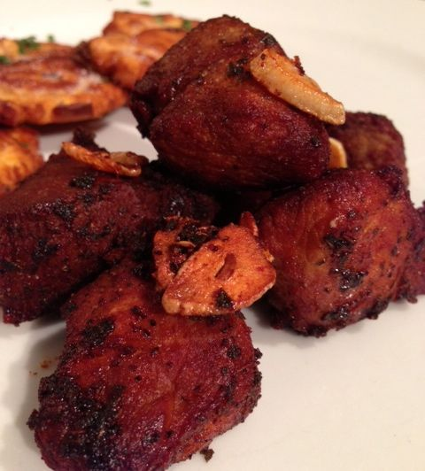

Ingredients:
1 lb. of stewing beef or pork (I like center-cut, boneless pork chop), cut into 2" cubes
2 Tbs. lemon juice
2 Tbs. lime juice
1 packet of Sazón GOYA con Culantro y Achiote
3 – 4 fresh garlic cloves, finely sliced
1 teaspoon of dried oregano
½ tsp. salt and ½ tsp. ground, black pepper

~ Peanut, corn or other vegetable oil for frying ~

PREPARATION:
In a small bowl, mix together well the juices, Sazón seasoning, garlic, oregano salt & pepper into a marinade. Put the meat into a freezer-quart, Ziploc bag, pour in the marinade, mix well to coat the meat thoroughly and refrigerate for about 6 – 8 hours, or (preferably) overnight. You can of course do the marinating in a covered bowl.

When ready to cook, bring the meat to room temperature. Add oil about 2” deep in a large saucepan. Let it heat up good on medium-high (about 300° F.) before adding the meat to fry in the oil. Fry the meat on medium-high heat for about 6 - 10 minutes, turning frequently, until every side is well browned and the fat crisps up nicely. Remove the fried meat to paper towels to drain excess oil. I like to add most of the garlic slices into the oil and fry them until just golden and crisp to use for garnishing the plated carne frita!

Fry tostones in the remaining oil! Also, goes nice with Goya-brand (boxed) Arroz con Gandules.

