Boris Karloff’s guacamole recipe

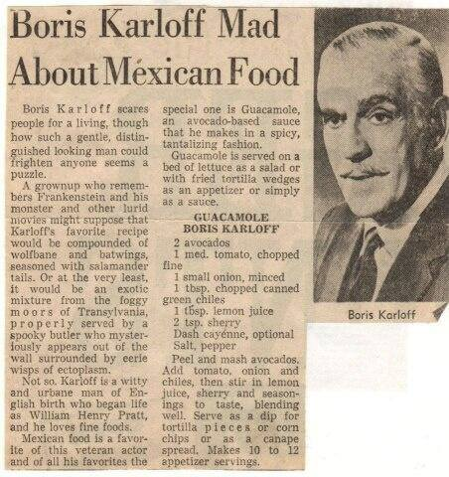
Ingredients:
2 avocados
1 medium tomato, finely chopped
1 small onion, minced
1 tbsp. chopped canned green chiles
1 tbsp. lemon juice
1 tsp sherry
Dash cayenne (optional)
Salt, pepper

Preparation:
Peel and mash avocados. Add onion, tomato and chiles, then stir in lemon juice, sherry and seasonings to taste, blending well. Serve as a dip for tortilla pieces or corn chips or as a spread. Makes 10 to 12 appetizer servings.

