Bloody Mary Chili for Two – my “go-to” chili recipe (the best one EVER)!

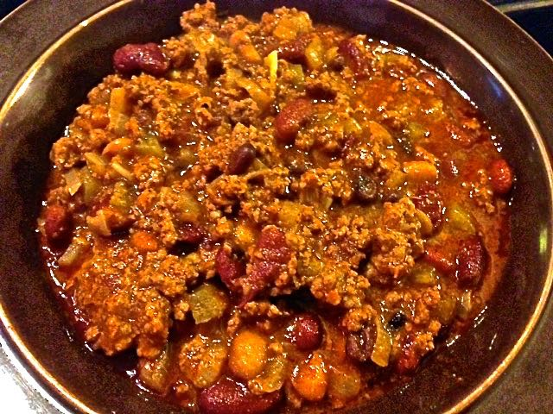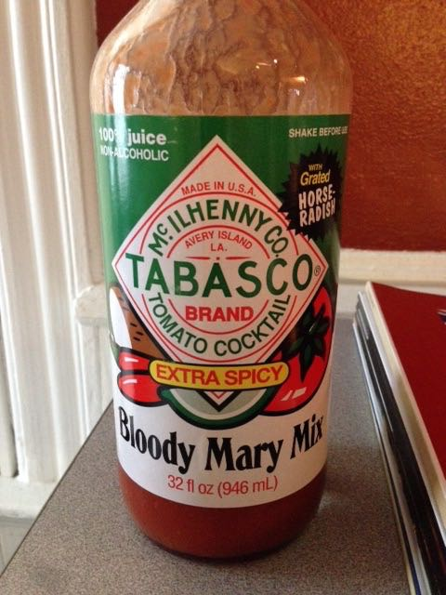

Ingredients:
Olive oil, for sautéing
1 rib celery, finely diced
1 smaller onion, finely diced
2 cloves garlic, crushed and minced
1½ pounds lean ground beef or bison
1½ teaspoons chili powder
½ teaspoon ground cumin
½ teaspoon ground oregano (preferably the Mexican kind)
1 cup any brand commercial bloody Mary mix, plus more if needed
4 tablespoons vodka – it cooks completely out, but it tenderizes the meat and beans
2 teaspoons Worcestershire sauce, or to taste
Two 16-ounce cans kidney, pinto, black beans (whatever you like – I like using ½ a can light kidney, ½ can black beans, ½ can dark kidney and ½ a can pinto beans)
2½ teaspoons Montreal steak seasoning – see recipe to make your own

Preparation:
Montreal steak seasoning is the result of both British and French culinary influences. You can buy it off the shelf, but to make enough for this recipe (or to season a couple of steaks for the grill), combine/grind the following in a spice grinder: 1 teaspoon salt, ½ teaspoon whole black peppercorns, ¼ teaspoon smoky Spanish paprika, ¼ teaspoon crushed red-pepper flakes (or a whole, dried red chili), ⅛ teaspoon whole coriander seeds, ⅛ teaspoon granulated garlic powder, ⅛ teaspoon granulated onion powder, ⅛ teaspoon whole fennel seeds. Set aside.

- In a large saucepan over medium heat, add a little olive oil and sauté the celery, onions and garlic until soft. Add the ground beef. Cook until browned; drain off the excess fat. Stir in the chili powder, cumin and oregano.

- In a cocktail shaker (without ice), mix up the bloody Mary mix, vodka, Montreal steak seasoning and Worcestershire, then add to the pot. Add the beans and stir together well. Cover and reduce the heat to low. Simmer for 1 hour, stirring occasionally. Add more Bloody Mary mix or water if needed during simmering.

