“Mexican Flag” Beef & Bean Burritos – recipe serves two (2 burritos each)

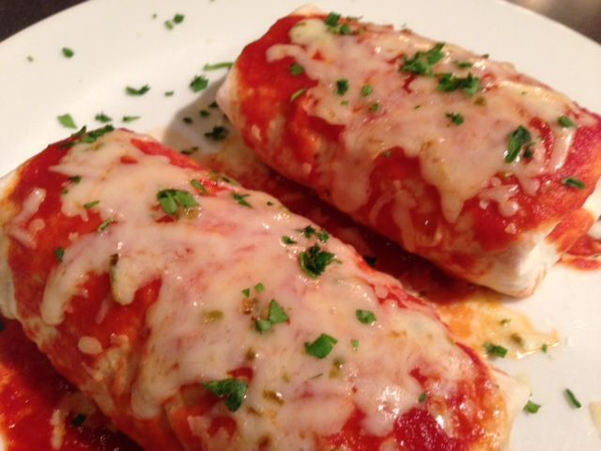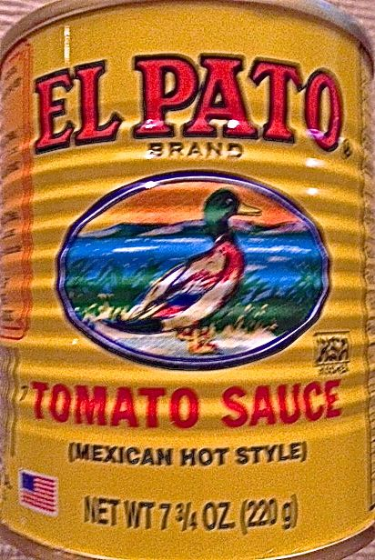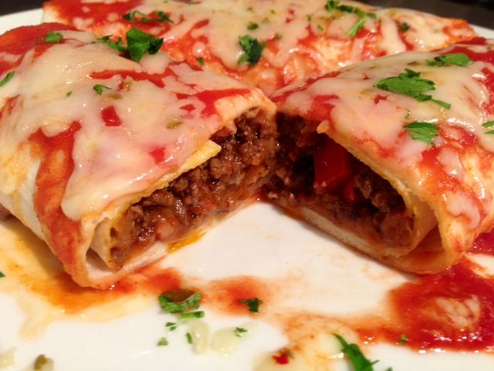

Ingredients:
½ pound lean ground beef
2 ounces (a very small) Spanish/yellow onion
1, 7¾-ounce can spicy, Mexican-style tomato sauce (El Pato brand) or enchilada sauce
Salt & ground, black pepper, to taste
¼ teaspoon ground cumin
¼ teaspoon oregano, preferably the Mexican variety
¼ teaspoon chili powder
2 – 4 cloves garlic, minced
Fresh chili peppers to taste, minced
½ of a 16-ounce can refried beans (freeze the other half for another time)
¼ teaspoon each lemon juice and limejuice
½ cup grated Mexican white cheese, Monterrey Jack or other cheese you like
4 large flour tortillas

Preparation:
In a small skillet, brown the onion, garlic and chilies seasoned with the cumin, oregano, chili powder and a little salt and pepper. Add the beef, season it with a touch more salt and pepper; brown, crumbling finely. I like to add in some finely chopped tomato at this point. Pour in 3 ounces of the sauce (save the rest to dress the burritos before serving) and simmer over low heat. Thin with a little water if it reduces down too much.

Mix the refried beans in a saucepan with the citrus juices and a dash of chili powder and salt. Add ¼ cup of the cheese and stir in until melted. Keep warm.

Heat tortillas in microwave for 30 seconds to a minute, until warm and pliable. Spread ¼ of the bean-cheese mixture on each tortilla. Add ¼ of the meat to each.

Fold over two short ends of each tortilla, then fold over the long ways and roll each up. For each serving, place two burritos on microwave-safe plates. Drizzle the reserved sauce equally over the top and sprinkle evenly with the remaining cheese. Microwave for 1½ - 2 minutes, until cheese is melted and burritos are very hot. Serve immediately garnished with chopped cilantro or parsley, if you like.

