Mexican Baked Cheese with Chorizo (Queso Fundido) for Two

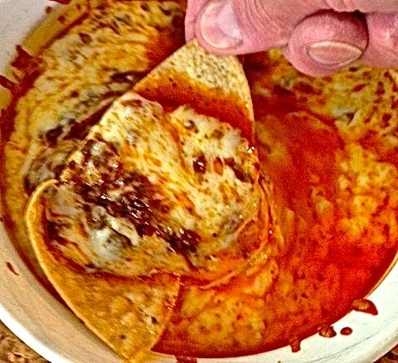

Enjoy this as you would Swiss fondue by dipping in with small pieces of cooked meats and/or raw or grilled pieces of vegetables on forks, or just dip in with tortilla chips or vegetable sticks. It also makes a great taco component.

Ingredients:
Vegetable oil, for greasing the baking dish
3 ounces Mexican-style (raw) chorizo, bulk/casings removed
3 tablespoons chopped onion, or one medium-large shallot, chopped
1 garlic clove, minced
About ½ pound (8 ounces) grated Oaxaca, quesadilla, mozzarella or any other kind of cheese that melts well
Hot sauce, to taste

Preparation:
Preheat the oven to 425° F. Grease a 5” – 6”-diameter baking ramekin.

In a dry, small saucepan, sauté the chorizo over medium-high heat until almost crisp. Add the onion and garlic to the pan, season with a little salt and ground, black pepper and sauté until soft.

Grate the cheese while the onion and garlic are softening (it helps the grating process to partially freeze the cheese). Lay ½ of the grated cheese in the baking dish and scatter it with ½ of the chorizo mixture (this is the point where I sprinkle in some hot sauce). Repeat with the remaining cheese and chorizo mixture. Cover pan with foil and bake until the cheese is bubbling, about 20 minutes.

