Baja Garlic Shrimp (Camarones al Mojo de Ajo) for Two

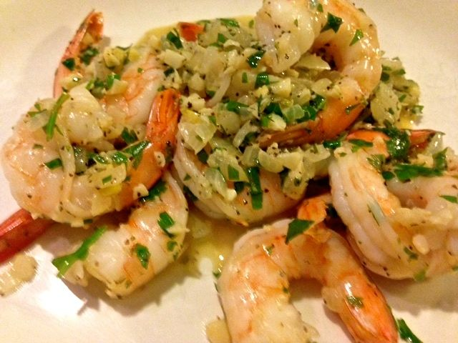

Ingredients:
2 tablespoons butter
8 ounces (½ pound – 16 in number) medium shrimp, peeled and deveined, tail on
Salt, to taste
Ground, black pepper, to taste
3 tablespoons minced onion
4 – 6 garlic cloves, minced
5 teaspoons white wine
4 teaspoons limejuice
1 tablespoon chopped fresh cilantro leaves

Preparation:
Melt the butter in small saucepan over medium heat. Season the shrimp with salt and pepper, to taste. Cook for about 4 minutes until almost fully cooked. Transfer the shrimp to a plate and tent it with foil.

Add the onion and garlic, season with a little salt and pepper, and cook until the onion is translucent. Stir in the wine and bring to boil, scraping up any brown bits on the bottom of the pan. Boil for 1 minute. Stir in the limejuice and cilantro. Return the shrimp to the pot and toss to coat with sauce. Continue to cook until the shrimp are fully cooked, about 1 minutes.

Transfer the shrimp to a serving platter and serve alone or with rice or beans, if desired. Don’t forget the Mexican hot sauce!

