Austin-Style Bisteca a la Mexicana Tacos for Two

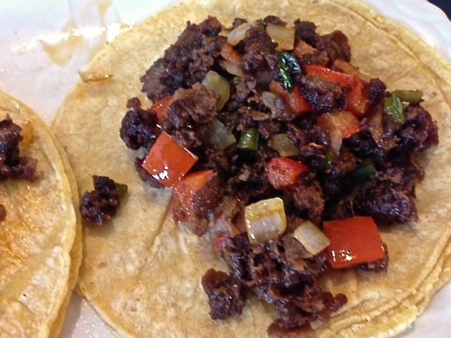 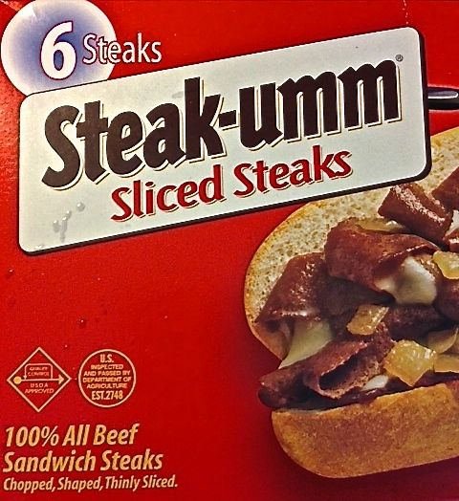 Originally made with steak, onion and bell-pepper strips, Bisteca a la Mexicana was the precursor to our Fajitas. In Austin, they make it with chopped sandwich steak and the ingredients for pico de gallo salsa.

Ingredients:
8 – 10 ounces sandwich steak, chopped (I use a 9-ounce box of “Steak-umm” brand)
1 small (about 2 ounces) white onion
1 serrano chili
1 medium Roma tomato
Fresh cilantro, to taste
1 tablespoon limejuice
4 – 8 corn tortillas (I double them, like they do in Mexico, if they’re really thin)
1½ teaspoons cornstarch
1 teaspoon chili powder
½ teaspoon salt
½ teaspoon paprika
½ teaspoon sugar
½ teaspoon crushed chicken bouillon cube
¼ teaspoon onion powder
⅛ teaspoon garlic powder
⅛ teaspoon cayenne pepper
⅛ teaspoon crushed red-pepper flakes
⅛ teaspoon cumin powder
1 tablespoon vegetable oil

Preparation:
Finely dice the onion, tomato, serrano and cilantro. Mix them with the limejuice, season with salt and pepper, set aside.

Thoroughly mix together the cornstarch, chili powder, salt, paprika, sugar, bouillon, onion powder, garlic powder, cayenne pepper, crushed red-pepper flakes and cumin powder. Coat the steak with the mix (I shake it all together in a paper bag).

Bring a medium skillet to medium-high heat and add in the oil. Add the coated steak and fry until caramelized. Add in the onion, tomato, serrano and cilantro mix. Continue sautéing for another minute or two, until everything is warmed though.

Warm the tortillas in the microwave for 1 minute. Serve the steak mixture evenly divided in the warmed tortillas with rice and beans on the side.

