Arroz con Pollo (Classic South-American Chicken & Rice)

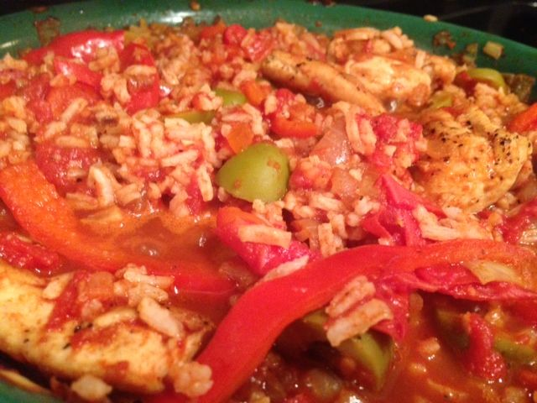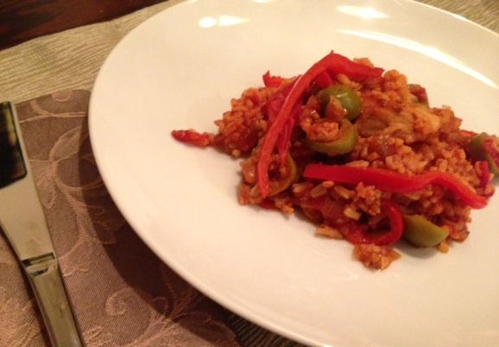

This is a one-pot meal that stands alone and needs nothing to accompany it. After college, I served for a little over a year as Deputy Director of International Relations & Trade Development for the City of New Orleans before going to law school up north. I remember my stately, eloquently-spoken director, Catherine Castro (a Cuban by heritage), telling me how she so very much relished the delicious strips of red bell pepper in this dish. That stuck with me and, to this day, is what makes me really appreciate it.

Ingredients:
½ pound chicken breast or “tenders,” cut into hunks (I just cut “tenders” in half)
1 small red bell pepper, cut into 1/8”-wide, long strips
1 small Spanish onion, finely diced/minced
2 - 4 cloves fresh garlic, minced
1, 14-oonce can diced tomatoes (I use hand-crushed San Marzanos from Italy)
½ cup sliced, green olives (with pimentos)
1 tablespoon lime juice
1 tablespoon smoky paprika
Olive oil (to brown the chicken in)
Salt, ground, black pepper and garlic powder to taste
Jalapeño slices (optional)
Red-pepper flakes (optional)
½ cup cooked, white rice (½ cup cooked rice = cooking ¼ cup raw rice)

Preparation:
Cook ¼ cup white rice ahead of time with ½ cup water, a pinch of salt and just ½ teaspoon oil.

Wash the chicken in cold, running water; season well with salt, garlic powder and black pepper.

In 10-inch skillet, place just a little olive oil and bring to medium-high heat. Brown chicken in skillet. Add onion and garlic, cook down until translucent. Add bell pepper, cook until soft.

Add the rest of the ingredients, including the cooked rice, and simmer over very low heat (covered) one half hour. Taste to adjust seasonings, adding a little more salt, if needed before serving.

