Annatto-Roasted Chicken Wings

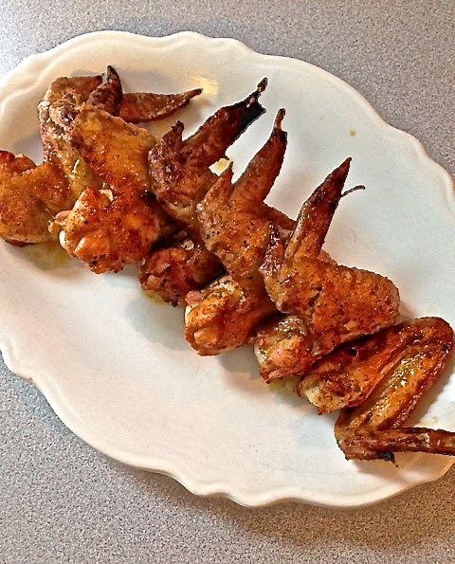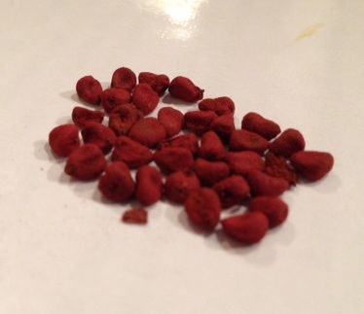

Ingredients per Serving:
6 whole chicken wings, drumettes and wingettes still attached
2 tablespoons olive oil
2 tablespoons unsalted butter
Juice of 1 regular lemon or of 2 smaller Meyer lemons (about 2 – 4 tablespoons)
1 teaspoon annatto seeds (sold at Latin grocery stores, it’s called achiote – pronounced “ah-chee-oh-tay” – in Spanish)
1 teaspoon ground cayenne
Salt

Preparation:
Preheat oven to 450° F. Line a baking sheet with aluminum foil and place a wire rack on top of the foil; set aside.

In a small saucepan, combine the olive oil, butter, lemon juice, and annatto seeds. Bring to a lively simmer over medium heat, stirring occasionally, until butter is melted and mixture is combined and imbued with a fiery orange tint from the annatto seeds. Strain the mixture into a small bowl, insuring that all the annatto seeds are strained out. Whisk in the cayenne pepper.

Arrange the chicken wings on the rack and brush the top sides with no more than half of the annatto mixture. Season with salt. Roast for 20 minutes. Dabble tops with a little more of the annatto mixture, then turn wings over, season undersides with salt and brush undersides with the rest of the annatto mixture. Cook until wings are browned and cooked through, 15 – 20 minutes more.

