American-Style Tacos & Healthy, Baked Tortilla Crisps

American-Style Taco Shells (like Taco Bell, Old El Paso and Ortega)
Microwave 8 tortillas (white or yellow corn) for 30 seconds to moisten. Fold over aluminum taco-shell forms (I make them by cutting up a disposable aluminum roasting pan) in oven pre-heated to 210° F. Bake for 1 hour.

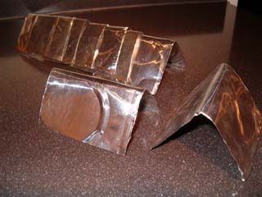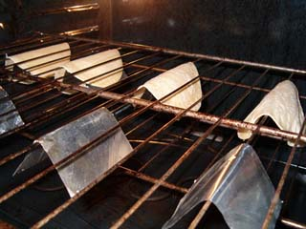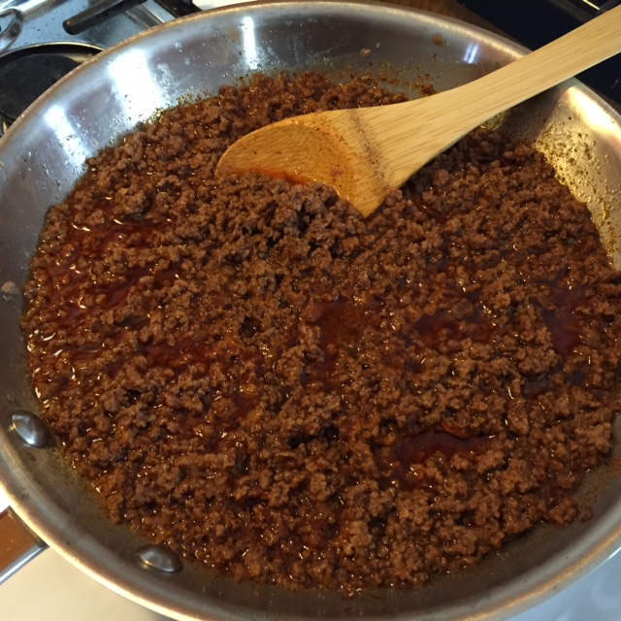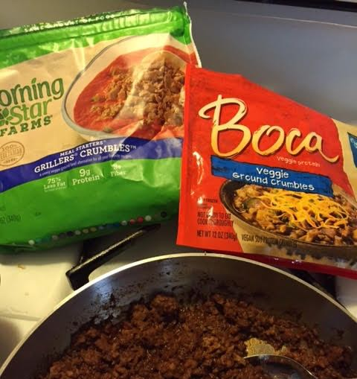

American-Style Taco Meat
Here’s how to avoid all the sodium (salt) in the commercial brands of powdered taco seasoning that come in the little packet-envelopes!

Ingredients for 4 Servings:
1 pound ground chuck (½ pound for only 2 servings)
¾ cup water (6 tablespoons for only 2 servings)
3 tablespoons Frank’s “Red Hot” sauce (4½ teaspoons for only 2 servings)
⅛ teaspoon ground cumin (half of a ⅛-teaspoon measure for only 2 servings)
2 teaspoons onion powder (1 teaspoon for only 2 servings)
2 teaspoons garlic powder (1 teaspoon for only 2 servings)
½ teaspoon ground cayenne (¼ teaspoon for only 2 servings)
1 tablespoon dark chili powder (1½ teaspoons for only 2 servings)
½ teaspoon table salt (not kosher or sea salt - ¼ teaspoon for only 2 servings)

Brown the meat in a 10” skillet, crumbling very fine (I use a potato masher, and I use faux meat crumbles to make a wonderful, low-fat/zero-cholesterol vegetarian version); drain as much of the fat as you can out of the pan. Add the remaining ingredients; let the mixture simmer on very low heat (just hot enough to maintain a gentle “percolating” of bubbles) 20 minutes. I think it tastes great without adding salt. But if you want to have a little saltier savor, add your salt after 10 minutes.

Baked Tortilla Crisps - When baked, they’re called totopos in Mexico.
Cut 10 white or yellow corn tortillas (1 packet) into quarter sections with kitchen sheers. Arrange in a single layer on two foil-lined baking sheets – try not to overlap them or they’ll stick together. Brush with melted butter, sprinkle with garlic salt and just a little, tiny bit of chili powder. Bake at 310° F. for 20 minutes. Let cool.

Or brush whole tortillas with melted butter, sprinkle with garlic salt and just a little, tiny bit of chili powder. Bake directly on the wrack (upper-most position) at 310° F. for 14 - 15 minutes. Let cool, then break up into smaller, bite-sized pieces.

