Albóndigas (Spanish meatballs in tomato sauce)

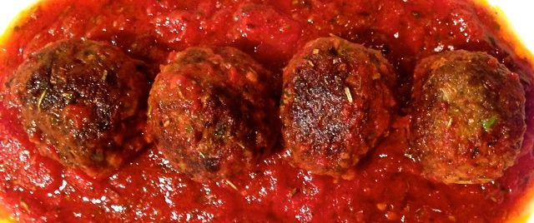

From an Arabic word, these albóndigas (“al-bone-dee-gahs”) are found in most tapas bars in Spain. Provide lots of fresh bread with them to mop up the juicy tomato sauce!

Ingredients:

For the Meatballs
1 small egg or half a large (see my cooking tips for eggs on page 49), beaten
4 ounces ground pork and/or beef
⅓ cup breadcrumbs
1 tablespoon grated Manchego or Parmesan cheese
1½ teaspoons tomato paste
2 cloves garlic, chopped fine
1 scallion, chopped fine
1 teaspoon dried thyme
¼ teaspoon ground turmeric
½ teaspoon smoky, Spanish paprika
Salt and ground, black pepper, to taste
1 teaspoon ground basil leaves
1 teaspoon ground rosemary

For the Sauce
14 - 16 ounces canned plum tomatoes, crushed by hand
2 tablespoons red wine
2 teaspoons chopped fresh basil leaves, or you can use more ground
2 teaspoons chopped fresh rosemary, or you can use more ground
1 teaspoon Spanish paprika

Preparation:
In a bowl, thoroughly mix together the meatball ingredients. Using your hands (I wear washed, latex gloves), divide the mixture in half, then divide each half in half, and so on until you have 8 portions (4 per serving). Roll each into a firm, 1½”-diameter ball.

Heat 2 tablespoons of olive oil in a medium-sized (8”) skillet over medium-high heat. Add the meatballs and fry for several minutes, until browned on all sides. Lower the heat, add the sauce ingredients, season generously with salt and pepper, then simmer gently for about 20 minutes, until the meatballs are cooked through. Serve hot.

