Spätzle
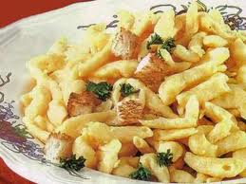 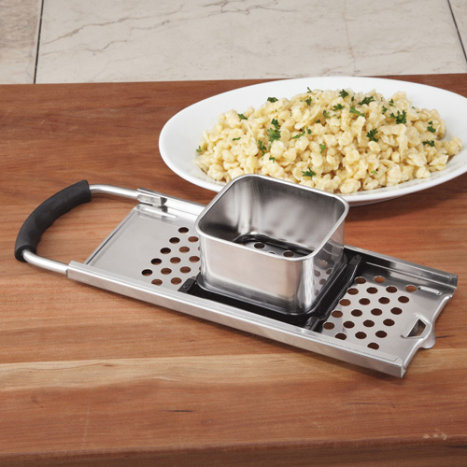 The recipe calls for this special Spätzle kitchen tool!
Recipe serves 6 – 8 (cut ingredients to 1/3 for only two servings, and do still use a large saucepan)

Ingredients:

3 eggs, beaten (1 egg for 2 servings)
1 cup milk (1/3 cup milk for 2)
3 cups flour (1 cup for 2 servings)
1/2 teaspoon salt (use ¼ tsp. for 2 servings)
¼ teaspoon nutmeg (use 1/8 tsp. for 2 servings)
2 chicken or beef bouillon cubes (1 cube for two servings)
Directions:

Place 12 cups of water in a large pot on a stove (6 cups if only making two servings), add bouillon and bring to a boil while mixing the rest of the recipe.

Beat eggs until foamy, then combine with the milk. Mix the flour, salt and nutmeg. Add to eggs/milk mixture a little at a time. The dough will be very stiff and elastic, and that’s how it needs to be!

Put batter into the square basket of the Spätzle Maker and place over the pot of boiling bouillon.

Slide basket back and forth, letting tiny dumplings fall into the boiling liquid.

When they are done cooking, they will rise to the surface of the liquid.

Use a large slotted spoon to dip them out into a large, covered bowl.

Repeat the process until all of the dough is cooked. Cold Spätzle can be reheated in the microwave 30 seconds on “high,” but stir in a couple good knobs of butter to keep them fresh and loose if they’ll be sitting some time before being served. Lightly butter and season to taste with salt & pepper at the table. Gravy is also very nice on them!

