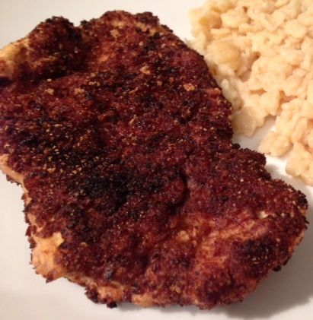 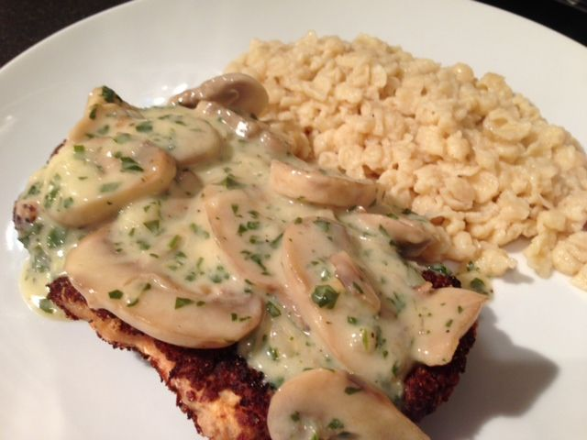 Schnitzel for Two!
Ingredients: (⬆ Jäger Schnitzel ⬆)
2 escalopes @ 3 oz. each (.20 lb. each on the butcher’s scale) of veal, pork or chicken, thinly pounded down (I like using two 2” cuts of pork tenderloin)
4 tablespoons flour
1 egg, beaten
4 tablespoons bread crumbs
¼ teaspoon each salt & ground, black pepper
oil, lard or other fat for frying

Pound the meat thin and cut the fringes carefully. Season lightly with a sprinkle of salt and pepper. Put flour on one plate, the beaten egg on a second and the breadcrumbs on the third. Dredge the meat first in the flour, then in the egg and finally in the breadcrumbs. Put breaded cutlets in a saucepan with a couple inches of oil heated to 350° F. and fry both sides of them (there should be enough fat in the saucepan so that the Schnitzel float in the saucepan and do not touch the bottom).

Cover Jäger Schnitzel with the mushroom-gravy recipe below and serve with German Spätzle dumplings, Bratkartoffeln (German pan-roasted potatoes), Sauerkraut or Rotkohle (sweet Bavarian red sauerkraut)!

Jäger Schnitzel is covered with this sauce - ingredients:
¼ cup (2 oz.) shallots or onion chopped
3 tablespoons butter
8 oz. mushrooms, sliced
½ cup broth
½ cup white wine
½ cup (4 oz.) + 2 tablespoons half and half or cream, divided
2 tablespoons flour
¼ teaspoon salt
salt and freshly ground pepper
3 tablespoons (1/8 cup) fresh parsley, chopped

Season onion with the salt & pepper and sauté until translucent in a small saucepan. Add in the sliced mushrooms, brown for 5 minutes. Add broth and wine, cook until alcohol disapates. Add ½ cup of half and half or cream, bring to a boil and simmer for several minutes. Mix remaining 2 tablespoons of cream with 2 tablespoons of flour (thin with water). Add flour slurry to mushroom mixture and bring to a boil, stirring to avoid clumps. Stir in the parsley. Keep warm while cutlets are cooked.

