Sauerbraten (serves 6 – 8) RECIPE REQUIRES TWO – THREE DAYS MARINATING!

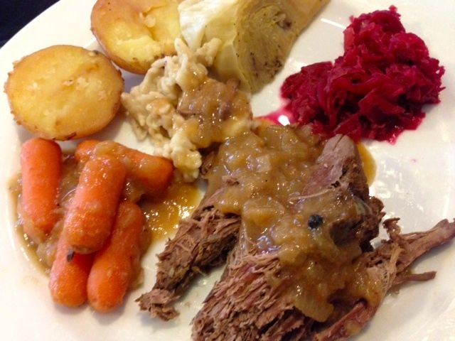

Ingredients:
2 pounds top round beef roast
2 teaspoons salt
1 teaspoon ground ginger
1½ cups beef broth
1 cup apple cider vinegar
2 onions, sliced
2 Tablespoon brown sugar
1 teaspoon whole peppercorns
8 whole cloves
2 bay leaves
16-ounce pkg. baby carrots
¾ cup crushed gingersnaps (about 15 cookies) – I put them in the food processor

Preparation:
Combine salt and ginger; rub over roast. Place in a deep glass bowl. In a saucepan, combine broth, vinegar, onions, sugar, peppercorns, cloves and bay leaves; bring to a boil. Pour over roast; turn to coat. Cover and refrigerate for 2 – 3 days (best when marinated 3 days), turning twice a day.

The morning of the last day, place the beef and its broth mixture from the bowl in a 4 to 5-quart slow cooker along with the carrots. Cover the crockpot and cook on low for 8 - 9 hours (if you have a new hot cooking crockpot cook on low for 6 - 7 hours until the meat is tender).

Remove and discard bay leaves. Remove the roast from the slow-cooker and let it rest in a 200° F. preheated oven. Remove the sauce into a saucepan, then add the gingersnaps (you may want to add more gingersnaps or brown sugar for the perfect sweet/sour balance). Cover and cook until thickened and heated. Slice the roast and dress with the gravy. Serve with hot cooked egg noodles or spätzle and sauerkraut.

