“Runzas” for Two - 2 buns per serving (in German, these are called Kraut Kuche)

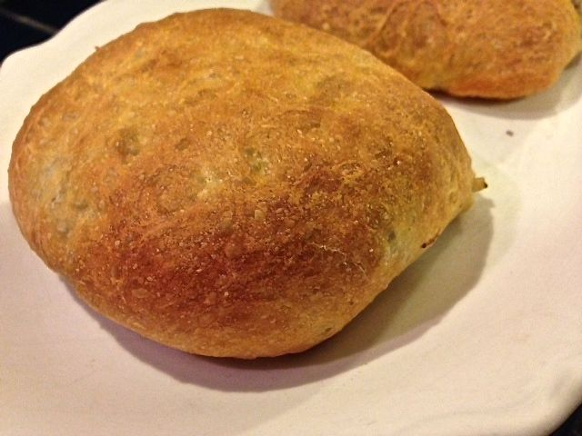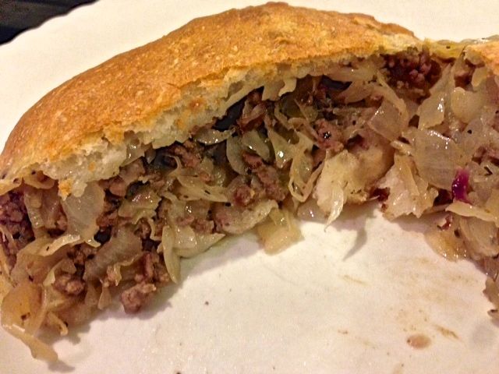

Runza is a Nebraska fast-food restaurant chain. “Runza” is what they call these buns. The recipe was brought to the American plains in the Midwest by German immigrants forced out of the Russian Volga River basin in the 19th and early 20th centuries.

Ingredients:
½ pound ground beef and/or pork
3 ounces chopped cabbage – I just use a handful of bagged, shredded coleslaw
3 ounces well-drained sauerkraut
1 medium-sized, white onion, finely chopped
1 teaspoon salt
½ teaspoon ground, black pepper
¼ teaspoon granulated garlic powder
¼ teaspoon celery salt
1 teaspoon spicy brown German-style mustard
22 ounces bread dough (I buy two 11-ounce tubes of the ready-made, refrigerated stuff)

Preparation:
Preheat oven to 350° F. In a medium-sized saucepan, season the meat with the salt, pepper, garlic powder, and celery salt; brown it well over medium heat.

Add in the cabbage, sauerkraut and onions; simmer with the meat until cabbage and onions are tender. Season with a little more salt and pepper, and stir in the mustard (watch and stir cabbage so that it does not burn).

Divide each tube of dough into two parts (I snip them apart with kitchen sheers). Squish each down like an accordion and roll each into a ball. With some force, roll each out into a 6” disc. Carefully place ¼ of the meat-cabbage mixture in the center of each dough round (make sure any holes in the dough are pinched closed first). Bake on a parchment- or foil-lined baking sheet for 20 - 25 minutes, until the buns are nicely browned.

I serve these with more sauerkraut, pickled German beets and a nice, green salad on the side.

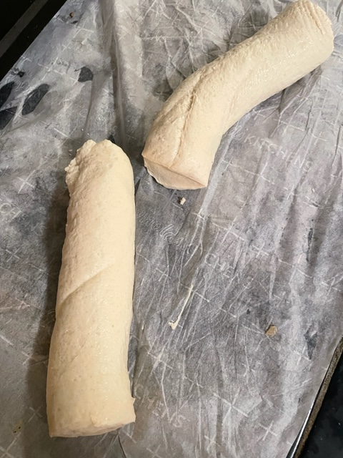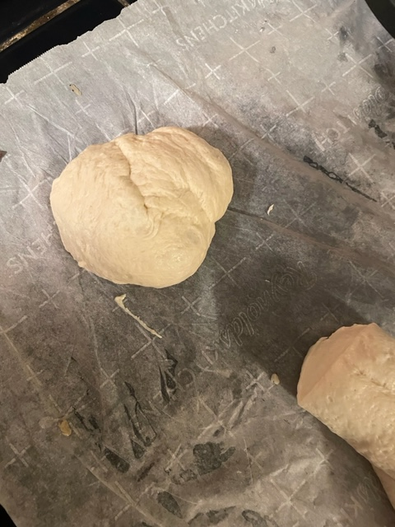
Snip the tube of dough in half. Roll each half into a ball.

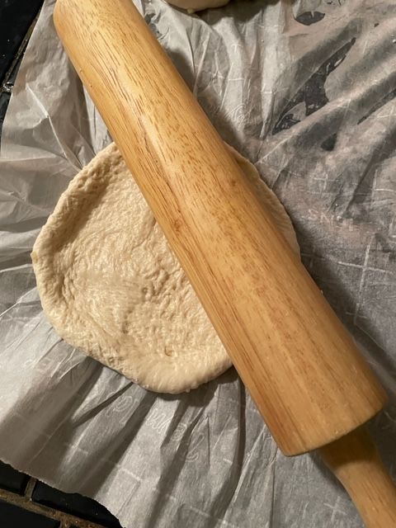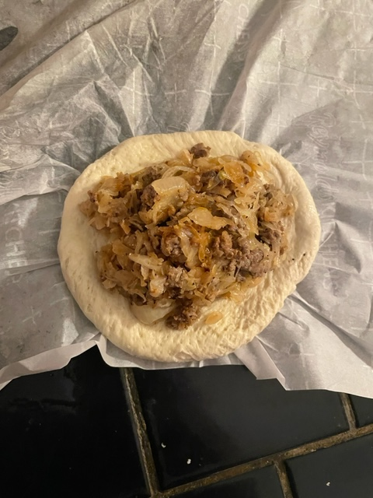
Roll each ball out into a 6” disc. Place ¼ of the filling in the center of each.

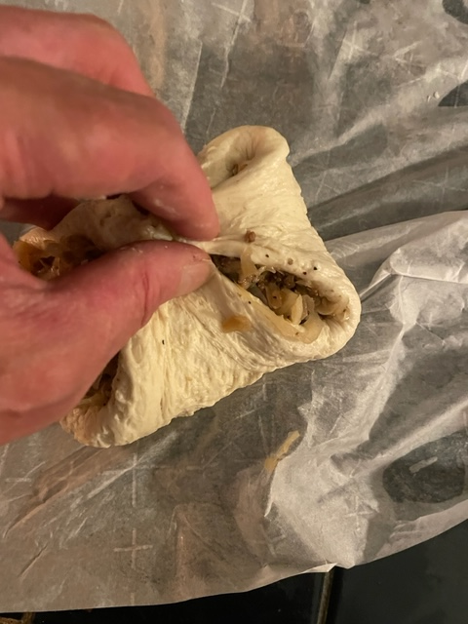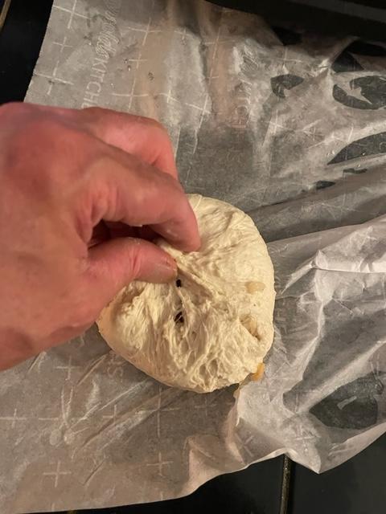
Bring four sides together and pinch together tightly. Bring remaining sides up and pinch closed, making a “purse.”

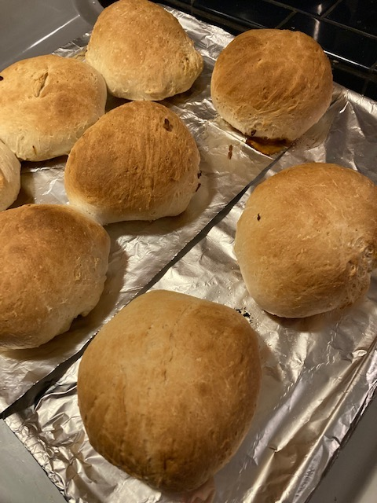
Bake buns seam-side down for 25 minutes.

My mom’s “Runza” dough recipe. It’s the Nebraska chain-restaurant original!

