Mom’s Sauerkraut and Spareribs for Two

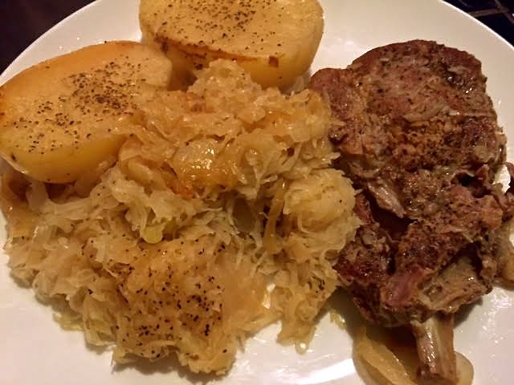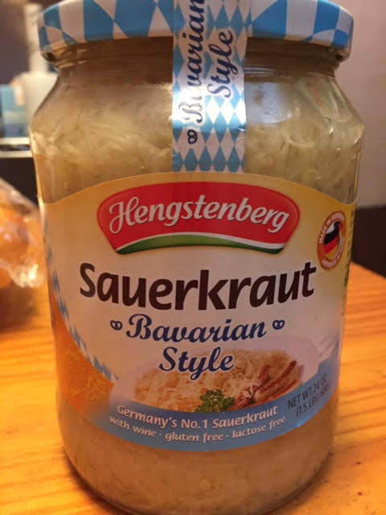

This has always been a cold-weather staple on the dinner table at my mom’s. Although she uses country-style pork ribs, she calls it “sauerkraut and spareribs.”
This is about as German as a meal can get!

Ingredients:
1 - 1½ pounds country-style pork ribs, well trimmed of fat (2 nice big ones)
24 ounces Bavarian-style sauerkraut
2 medium-sized russet potatoes, peeled and cut in half lengthwise
1 medium onion, peeled, cut in half and very thinly sliced
Granulated garlic powder
Ground, black pepper
Salt

Preparation:
Preheat oven to 325° F.

Season the ribs generously with salt, pepper and garlic powder. Grease a Dutch oven and layer the ribs on the bottom. My mom doesn’t brown them first, but I like to brown them in the Dutch oven on the stovetop to give them some color and an extra dimension of flavor before everything goes in the oven.

Layer half the onions over the ribs and season them well with salt and pepper, then layer half the sauerkraut over the onions (I like a good sprinkling of black pepper on my kraut). Put another layer of onions seasoned with salt and pepper and top them with another layer of sauerkraut.

Tuck the potato halves in around the sides of the pot and season them with salt and pepper. Bake for 2½ hours. Serve with rye bread, butter and, of course, bier.

