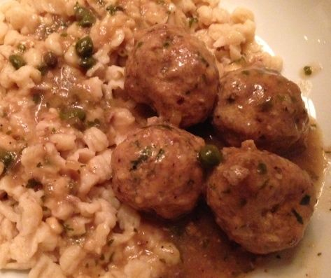 Königburger Klopse (German meatballs – recipe serves 2)

Ingredients:
¼ lb. ground sirloin or ground round and ¼ lb. ground pork
¼ cup unseasoned breadcrumbs
1 egg
½ teaspoon butter
1 tablespoon finely minced shallot
1½ teaspoons chopped parsley
¼ teaspoon salt
¼ teaspoon ground, black pepper
¼ teaspoon paprika
zest of 1 small lemon and juice of the small lemon, divided in two
1/8 teaspoon grated nutmeg
¼ teaspoon Worcestershire sauce
1 cup beef stock/bouillon
2 tablespoons or more chopped parsley
2 tablespoons capers and/or pickle relish
2 tablespoons flour

Preparation:
Melt the ½ teaspoon butter in a small saucepan over medium-high heat. Add in the shallot, season with just a touch of salt and pepper and fry down until caramelized. Remove from heat and let cool a bit.

In a large mixing bowl, beat the egg until frothy. Add in the breadcrumbs, the 1½ teaspoons chopped parsley, ¼ teaspoon salt & pepper, paprika, lemon zest and juice of half the lemon, nutmeg, Worcestershire sauce, fried shallot and meat. Mix thoroughly with your hands. Divide the mixture equally into 8 meatballs (4 per serving).

In the saucepan, bring the stock/bouillon to a light boil. Carefully set the meatballs down into the stock/bouillon and simmer, covered, on medium-low heat 15 minutes, turning them once or twice. Remove the meatballs and keep warm at the side.

Measure the amount of stock/bouillon you have after removing the meatballs. For one cup, you’ll need to whisk in 2 tablespoons of flour at the boil to make a thickened gravy. Once the sauce is a thick gravy, stir in the capers/relish, the second half of lemon juice and additional chopped parsley. Check seasoning, then add the meatballs back in and continue to simmer another 5 minutes, or until the meatballs are warmed through.

Serve the meatballs with boiled noodles or Spätzle, all covered evenly with the gravy.

