Kaiser Crêpes-Pfanne Pancake - Recipe for 8 pancakes.

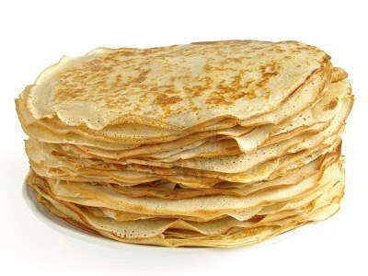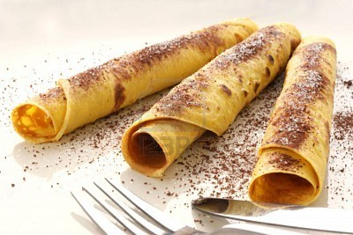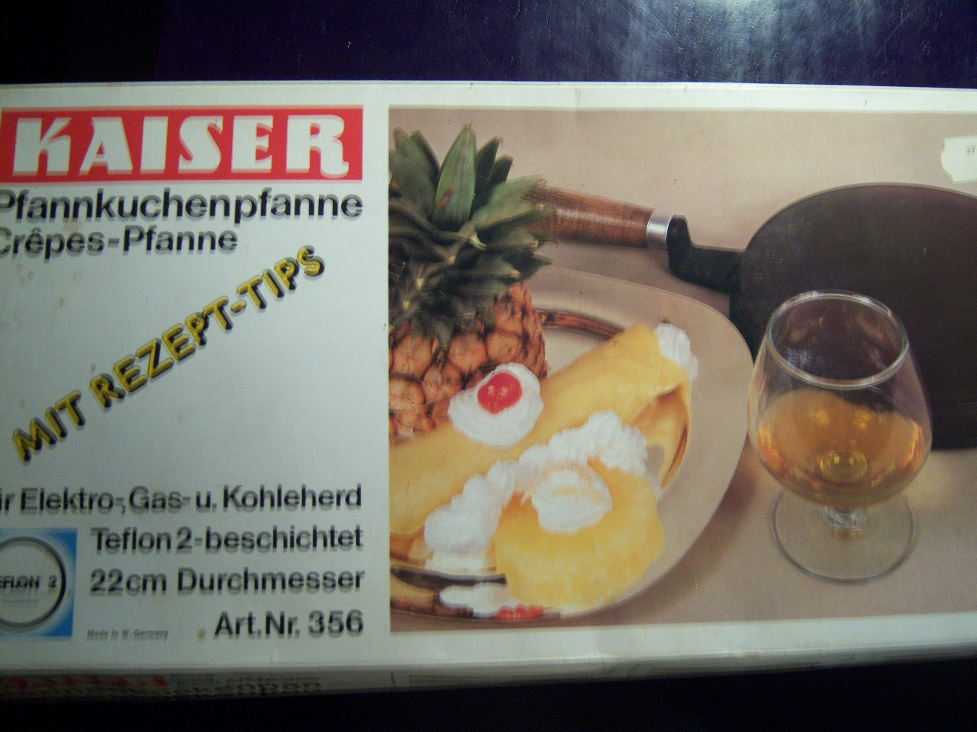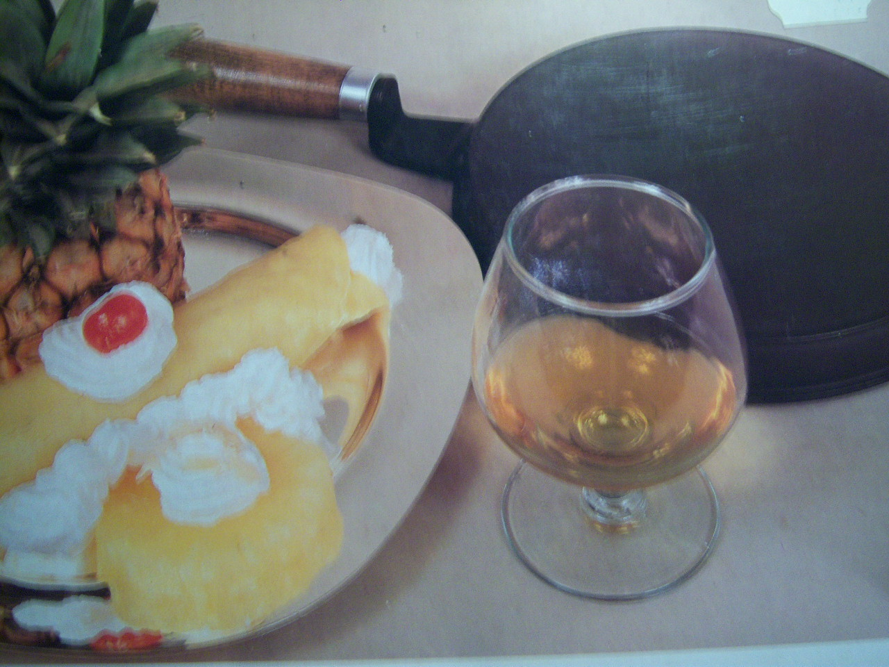

These crêpes are made with an old Kaiser-brand, dome-top pan I found at an antiques shop (box is pictured above), but I’m sure you could make the crêpes for the recipe below with an 8” skillet – just spread a very thin amount of the batter in it preheated.

INGREDIENTS:
100 g. / ½ cup Flour
200 ccm / 1 cup Milk (can substitute all or part with chicken broth or beef bouillon!)
½ teaspoon salt
3 eggs, beaten
2 Tablespoons melted butter

PREPARATION:
Beat all ingredients together well. Place the mixture in a shallow dish or bowl (something that you can easily dip the domed side of the pan in) and allow to rest 30 minutes to 1 hour.

Heat the pan up well, domed side up, on an electric, gas or coal-burning stove burner on medium-high heat so that it’s hot, but not overheated (I set electric burners to “6”). Remove from heat and dip the domed side of the pan into the dough mixture well. The mixture sticks immediately to the hot pan’s surface!

Put the pan back on the hot burner; cook until crêpe is set (not necessarily brown). Remove pan from heat, turn upside down over a plate and pry free of the dome with a fork or spatula. Repeat for the next crêpe!

Crêpes Jacques are filled with sliced bananas & whipped cream.
Crêpes Napolitaines are filled with orange marmalade and served with orange slices on the side.
Prinzen Crêpes (for 8 servings) are filled with a mixture of 2 raw egg yolks whisked with 1 TBS. warm water until they turn light in color, then 100 g. / 7 oz. melted butter, 200 g. / 14 oz. crab meat, salt & pepper to taste are then mixed in well – fill the crêpes evenly with the mixture and top with a good sprinkling of cheese, then broil until melted, gooey and golden. Serve crêpes garnished with a little dill weed.

Other Fillings: Nutella, berries, baked apple slices, chocolate sauce, whipped cream. Sprinkle with cinnamon or powdered sugar. Savory crêpes: Smoked salmon, tuna, deli meats, chilies, grated cheese, fresh herbs.

