Gulaschsuppe – German Goulash Soup (recipe serves two).

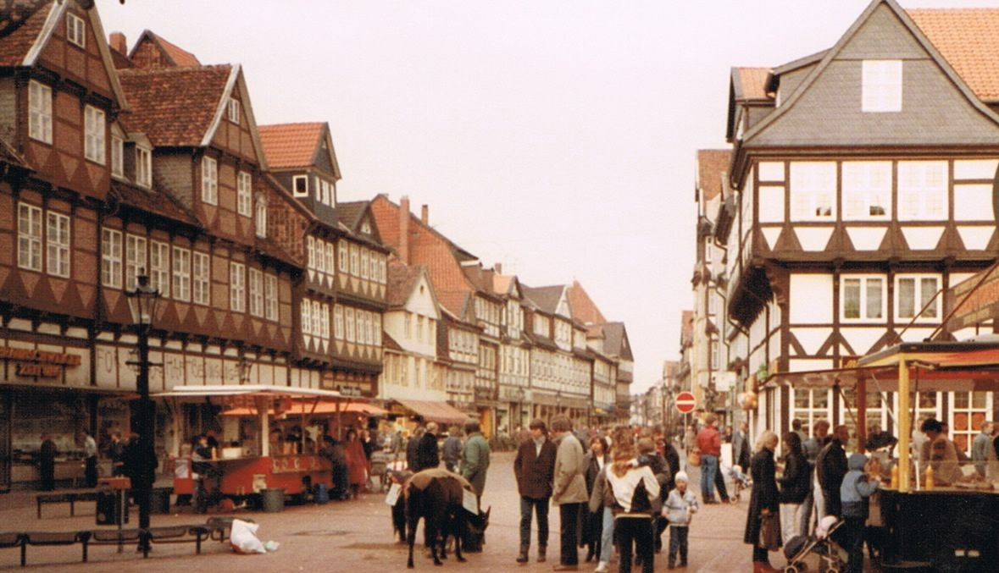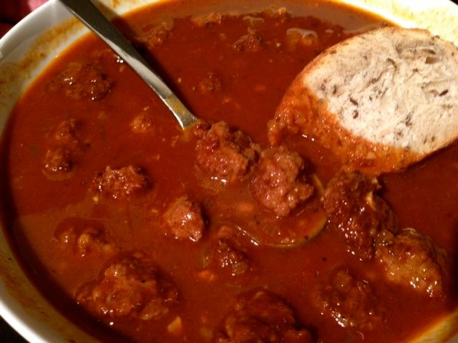

This recipe is just how I remember it served in the cozy Kneipe pubs when I lived in Germany in the mid 1980s!

Ingredients:
8 ounces ground sirloin beef
⅓ cup unseasoned breadcrumbs
1 egg
¼ teaspoon each of onion powder, salt & ground, black pepper
2 tablespoons vegetable oil or butter
1 medium onion, finely chopped/minced
1 - 2 cloves fresh garlic, minced
2 tablespoons mild paprika
½ teaspoon caraway seeds
1½ teaspoons tomato paste
1 small bay leaf
1⅓ cups water
2 cups beef broth
¼ cup good, drinkable red wine
2 tablespoons flour

Preparation:
Combine the tomato paste and wine into a slurry in a little cup or bowl; set it aside until the end of the cooking time. In a large bowl, knead the beef, breadcrumbs, egg, onion powder, ¼ teaspoon salt and ¼ teaspoon pepper together well.

Add the fat to a large saucepan or small stew pot on medium heat. Drop the meat mixture by the level-teaspoon into the pot and brown as you go (do not stop to make little meatballs, but be sure to make each no more than a level-teaspoon). You’ll have to work fast! When there is little-to-no pink color left in the meat, sprinkle it lightly with more salt and pepper. Add the onions and garlic and fry until the onions are translucent.

Add the paprika, bay leaf, caraway seeds, water, and broth. Bring to a boil, cover, and simmer on very low heat for 1½ hours.

An half hour before the soup is finished simmering, stir in the slurry you made earlier from the tomato paste and red wine. In a small bowl, stir a few tablespoons of the hot soup broth with the flour; be sure to whisk it until it’s good and smooth. Add the flour mixture to the soup pot, stir, turn up the heat a couple of notches and continue simmering an half hour. Season to taste with more salt and pepper. Remove the bay leaf before serving!

