German Baked Pancake – recipe makes enough for one, big pancake that serves 2

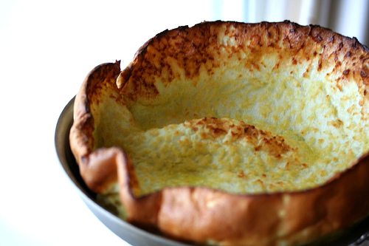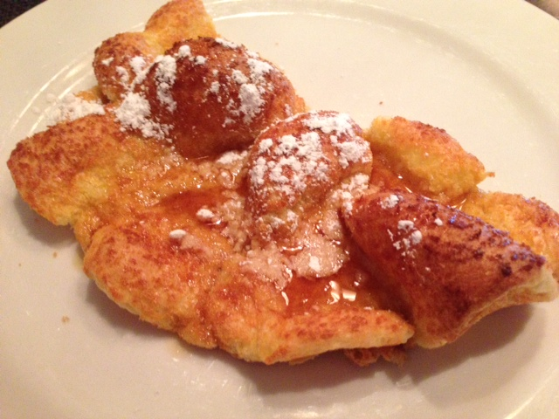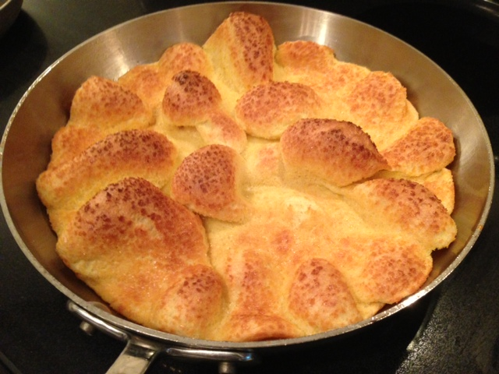
Ingredients:
½ cup of all-purpose flour, sifted
3 eggs, lightly beaten
½ cup milk, cream or half-and-half
2 tablespoons melted butter
1 tablespoon sugar
¼ teaspoon of salt

Preparation:
Preheat oven to 450° F. If you have a convection oven, set it at 425° F. – the pancakes rise even higher on the convection setting.

Lightly beat eggs in a large bowl. Stir in the milk, melted butter, salt and sugar. Gradually add flour to egg mixture, a spoonful at a time. Make sure the flour is well incorporated in the batter with no lumps, but do not over-mix, as you want to keep the pancake light.

Lightly grease/butter a 12” ovenproof skillet with cooking spray (but expect the pancake to stick a little, anyway). Pour batter in the skillet. Bake 12 -18 minutes, just until the edges are golden. Check your pancake at the 12-minute mark. It’s fun to turn on the oven light and watch the pancake form!

Note:
These always turn out differently each time for me. Try experimenting with different pans and skillets – just as long as you use something at least 9″ wide and ovenproof. You could also divide the batter into two smaller pans and have them bake side by side. Just make sure that your oven rack is in the middle position or lower. Top with warm, maple syrup and powdered sugar.

