Engadine Barley Soup (Engadiner Gerstensuppe) for Two

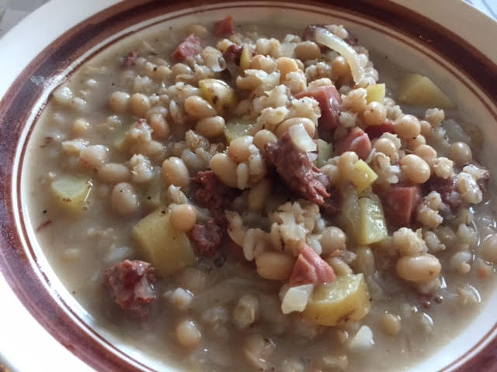

This is a thick, creamy stew from the Engadine valley in eastern Switzerland.

Ingredients:
4 ounces ham, diced
4 ounces ground beef or finely chopped stewing beef
3 – 4 ounces pearl barley
4 ounces small, white navy or great northern beans (I put in a 15-ounce can)
4 ounces potatoes, diced
¼ of a small cabbage, shredded
1 teaspoon salt
½ teaspoon ground, black pepper
½ teaspoon granulated garlic powder
½ teaspoon granulated onion powder
5 teaspoons cream
1 tablespoon all-purpose flour
4 cups water or broth
Chopped vegetables of your choosing (I add in half an onion, a few cloves fresh garlic, half a green bell pepper and a rib of celery – they also put carrots in this)

Preparation:
If not using canned beans, soak dry beans overnight covered in water, then drain.

Brown the beef in a large pot or Dutch oven with your choice of chopped vegetables, then add in the ham, barley and beans; bring to the boil in the 4 cups water, adding the salt, pepper and other seasonings. Cover the pot and simmer for the period of time called for by the barley’s package directions, stirring occasionally and adding more hot water as the barley plumps to keep the broth plentiful.

Once the barley is tender, add in the shredded cabbage and potatoes. Let simmer on low another 30 minutes, or until the potatoes are tender. Blend the cream and flour together thoroughly and stir it into the soup to thicken it (the mixture will be a thick clump, but will dissolve right away in the pot). Bring to the boil once more, and serve. I also like to add in about ¼ cup of shredded gruyère cheese for extra flavor.

